
Touchstones REACH
Touchstones REACH (Religious Education Arts Clearing House)

Lifespan RE Resources for Mercy

Introduction
This packet provides resources on the theme of Mercy. As the Introduction to the Theme in the journal explains, “It is hidden. The ‘it’ is mercy. It is hidden within our second principle in which we affirm ‘justice, equity, and compassion in human relations.’ Mercy is implicit rather than explicit. It occupies the space between equity and compassion. And it is informed by the principle of the inherent worth and dignity of every individual. If this were not true, mercy would seldom have any standing.”
Mercy is a disposition, a motivator, and an action. The disposition is informed by compassion and kindness; as a motivator to encourage mercy; and the action taken through forgiveness and/or the compassionate application of justice. Mercy, like grace, is not deserved. It is a quality that defines the giver, not the receiver.
Mercy involves an existential choice:
- extend compassion, kindness, or forgiveness toward someone who you do not “have” to;
- withhold harsh treatment that you have a right to inflict; or
- withhold mercy by punishing, harming, or ignoring her or him (as in the story of the Good Samaritan).
Justice, in terms of punishment, is rendered when people receive their due, according to the law. Mercy, on the other hand, tempers justice through forbearance or moderation. As above, an act of mercy applies compassion and kindness to justice.
Christopher Peterson & Martin E.P. Seligman, authors of Character Strengths and Virtues, list mercy as a subset of the character strength of forgiveness, which is listed under the virtue of Temperance that includes other strengths that protect against excess. So, as above, mercy is expressed through forgiveness and through justice, especially restorative justice and social justice through, among other things, the works of mercy outlined below.
The focus of Tapestry of Faith on mercy is limited. The curriculum focus is through some of the parables of Jesus that stress mercy. Anne Lamott also writes about biblical characters (see below) that exhibit mercy: Ruth (7:22) and Joseph (i.e., coat of many colors) (7:26). Because forgiveness is often so intertwined with mercy, you will also find curricular materials from Tapestry of Faith on forgiveness. Materials on the web tend to focus solely on God’s mercy, yet the doorway to introducing mercy is best done through the works of mercy noted below, many of which are informed by the ancient and honorable practice of hospitality, as well as through forgiveness, through kindness, and through justice that is tempered with compassion. You will find children’s books on each of the seven works of mercy in section 4.0 below.
In Hallelujah Anyway: Rediscovering Mercy, Anne Lamott writes, “Mercy is radical kindness. Mercy means offering or being offered aid in desperate straits. Mercy is not deserved. It involves absolving the unabsolvable, forgiving the unforgivable. Mercy brings us to the miracle of apology, given and accepted, to unashamed humility when we have erred or forgotten.”
Works of mercy (sometimes known as acts of mercy) were, except for #7, enumerated by Jesus (see Matthew 25: 35-36. (The seventh work of mercy comes from the Book of Tobit and from the mitzvah of burial, although it was not added to the list until the Middle Ages.) The works of mercy include
- To feed the hungry.
- To give water to the thirsty.
- To clothe the naked.
- To shelter the homeless.
- To visit the sick.
- To visit the imprisoned, or ransom the captive.
- To bury the dead
This list makes it clear that mercy is an important component of social justice.
The admonition to do mercy comes from the Hebrew prophet, Micah (740-670 BCE), who said, “What does the Lord require of you but to do justice, and to love mercy, and to walk humbly with your God? (Micah 6:8)” Further, per Leviticus 25:1-13, every 50th year was to be a Year of Jubilee, which emphasized mercy: releasing people from their debts, releasing all slaves, and returning property to those who owned it. The entire year was also dedicated to Sabbath rest.
Laura Kuehn, LCSW writes, “Mercy can be a difficult word for children to understand. But each day presents you with an opportunity to make the concept come to life.
“The next time your child disobeys, instead of giving him [or her] the consequence he [/she] deserves, tell him [/her] that you are going to extend him [/her] mercy—you will not give him [or her] what he [/she] deserves. …
1) If someone does something mean to you, don’t treat them badly in return.
2) If someone does something mean to you, do something nice to them instead.
3) Offer forgiveness to someone who has wronged you before it is asked for.”
Source: https://www.cornerstonesforparents.com/helping-kids-understand-mercy-lesson-2-samuel
PG Kids writes,
- “Mercy is not punishing someone who deserves it.
- Mercy says, ‘I could punish you, but I choose not to.’
- Mercy is forgiving someone instead of making them feel bad.
- Mercy is making a habit of being nice.”
Source: https://www.pursuegodkids.org/happy-are-the-merciful/
Darcy Osby in, The Mercy Rule: How to Teach the Works of Mercy, writes, “Are you familiar with the ‘mercy rule’ in sports? The mercy rule states that if one team is ahead by an insurmountable lead, the game ends so as to not drag out the humiliation of the losing team. Since many children play sports, they are familiar with the mercy rule. It can be a great starting place for teaching mercy and the fact that we are called to show …compassion to everyone, even our opponents and those people we consider ‘enemies.’
“The mercy rule example helps children think about how to show mercy to others. Begin the discussion by asking them about how they experience the mercy rule in sports. How does it feel to be on the losing team? How should you treat the players of the losing team if you are on the winning team? What would the game be like if it kept going without a mercy rule?
“Extend the discussion by asking the children what the world would look like if there were a mercy rule for life. Who in life would need mercy? Who are the people who “fall behind” in the game of life? How could we show them mercy? Ask children to come up with a mercy rule for life. Younger children may need more prompting such as, “How can we show mercy to someone who is hungry? How can we show mercy to someone who is sad?”
Source: https://catechistsjourney.loyolapress.com/2016/01/the-mercy-rule-how-to-teach-the-works-of-mercy/

List of Resources
1.0: Pins
Resources for Children
2.0: Children’s Homilies, Sermons, Time for All Ages & Resources
No resources found
3.0: Wisdom Stories

3.1: The Good Samaritan (576 words)

3.2: Jesus and the Sheep (582 words)
Excerpts from the New Revised Standard Version of the Bible.

3.3: The Prodigal Son (aka the Lost Son) from Luke 15:11-32 (New Revised Standard Version) (514 words)

3.4: The Pitcher of Tears by Megan McKenna (990 words)
3.5: The Woman Who Outshone the Sun: The Legend of Lucia Zenteno by Nancy Jilk (1,058 words)
4.0: Children’s Books about Works of Mercy

To feed the hungry

4.1: Maddi's Fridge by Lois Brandt, author and Vin Vogel, illustrator (2014)

4.2: Faith the Cow by Susan Bame Hoover, author and Maggie Sykora, illustrator (1995)

4.3: Beatrice's Goat by Page McBrier, author and Lori Lohstoeter, illustrator (2004)

4.4: Tight Times by Barbara Shook Hazen, author and Trina Schart Hyman, illustrator (1979)
4.5: The Last Stop on Market Street by Matt de la Peña, author and Christian Robinson, illustrator (2015)
4.6: Uncle Willie and the Soup Kitchen by Dyanne Disalvo-Ryan, author (1997)
4.8: Poverty and Hunger by Louise Spilsbury, author and Hanane Kai, illustrator (Children in Our World Series) (2017) (hunger and poverty)

4.9: How Can We Help the Hungry handout

To give water to the thirsty

4.10: The Water Princess by Susan Verde and Georgie Badiel, authors and Peter H. Reynolds, illustrators

4.11: Anna Carries Water by Olive Senior, author and Laura James, illustrator (2014)

4.12: The Water Walker by Joanne Robertson (2017)

4.13: Water by Subhash Vyam (2018)

4.14: Water’s Children: Celebrating the Resource that Unites Us All by Angèle Delaunois, author, Gérard Frischeteau, illustrator and by Erin Woods, translator

4.15: A Cool Drink of Water by Barbara Kerley (2002)

To clothe the naked
4.16: Coat of Many Colors by Dolly Parton, author and Brooke Boynton Hughes illustrator (2016)

4.17: The Rag Coat by Lauren A. Mills, author (1991)

4.18: Those Shoes by Maribeth Boelts, author and Noah Z. Jones, illustrator (2009)

4.19: Sam and the Lucky Money by Karen Chinn, author and Cornelius Van Wright & Ying-Hwa Hu, illustrators (1995)

4.20: The Hundred Dresses by Eleanor Estes, author and Louis Slobodkin, illustrator (1944/2004)
4.21: Four Feet, Two Sandals by Karen Lynn Williams & Khadra Mohammed, authors and Doug Chayka (2007)

To shelter the homeless
4.22: A Shelter in Our Car by Monica Gunning, author, and Elaine Pedlar, illustrator (2013)
4.23: The Lady in the Box by Ann McGovern, author, and Marni Backer, illustrator (1997)
4.24: A Place to Stay: A Shelter Story by Erin Gunti, author and Estelí Meza, illustrator (20:19)
4.25: The Teddy Bear by David McPhail (2002)
4.26: Yard Sale by Eve Bunting, author, and Lauren Castillo, illustrator (2015)

4.27: The Butterfly by Patricia Polacco (2000)

To visit the sick
4.28: A Sick Day for Amos McGee by Philip C. Stead, author and Erin E. Stead, illustrator (2011)

4.29: Bear Feels Sick by Karma Wilson, author and Jane Chapman, illustrator (2007)
4.30: How Do You Care for a Very Sick Bear? by Vanessa Bayer, author and Rosie Butcher, illustrator (2019)
4.31: Through My Window by Tony Bradman, author & Eileen Browne, illustrator (1986)
4.32: The Lemonade Club by Patricia Polacco (2007)
4.33: The Remember Balloons by Jessie Oliveros, author and Dana Wulfekotte, illustrator (2018)

To visit the imprisoned, or ransom the captive
4.34: Mama’s Nightingale by Edwidge Danticat, author and Leslie Staub, illustrator (2015)

4.35: Visiting Day by Jacqueline Woodson, author and James Ransome, illustrator (2015)

4.36: Mango Moon by Diane de Anda, author and Sue Cornelison, illustrator) (2019)
4.37: The Night Dad Went to Jail: What to Expect When Someone You Love Goes to Jail by Mlissa Higgins, author and Wednesday Kirwan, illustrator (2013)

To bury [and mourn] the dead
4.39: Ida, Always by Caron Levis, author and Charles Santoso, illustrator (2016)
4.40: The Invisible String by Patrice Karst, author and Geoff Stevenson, illustrator (2000)
4.41: The Goodbye Book by Todd Parr (2015)

4.42: The Memory Box: A Book About Grief by Joanna Rowland, author and Thea Baker, illustrator (2017)
4.43: I'll Always Love You by Hans Wilhelm (1985)
5.0: Music, Videos, and Related Resources for Children
6.0: Curriculum & Theme-Based Classroom Activities for Children for Mercy & Forgiveness

from Tapestry of Faith
Mercy
6.1: Creating Home: A Program on Developing a Sense of Home Grounded in Faith for Grades K-1
6.1.1: Session 14: Comings and Goings
6.2: Moral Tales, A Program on Making Choices for Grades 2-3
6.2.1 Session 8: Do unto Others
6.3: Amazing Grace: A Program about Exploring Right and Wrong for Grade 6
6.3.1: Session 8: UUs In Action
6.4: Building Bridges: A World Religions Program for 8th-9th Grades
6.4.1: Workshop 16: Evangelical Christianity
6.5: A Chorus of Faiths: A Program That Builds Interfaith Youth Leaders
6.5.1: Workshop 2: We Need Not Think Alike to Love Alike

6.5.2: Workshop 6: Spreading the Good News
Forgiveness
6.6: Wonderful Welcome: A Program for Children Grades K-1
6.6.1: Session 3: The Gift of Forgiveness
6.7: Love Surrounds Us: A Program on the UU Principles and Beloved Community for Grades K-1
6.7.1: Session 4: Forgiveness
6.8: Moral Tales: A Program on Making Choices for Grades 2-3
6.8.1: Session 5: Forgiveness
6.9: Faithful Journeys: A Program about Pilgrimages of Faith in Action for Grades 2-3
6.9.1: Session 2: Unconditional Love, a Gift from Our Universalist Heritage
6.10: Love Will Guide Us: A Program for Grades 2-3 that Applies the Wisdom of the Six Sources to the Big Questions
6.10.1: Session 13: Responding with Love
6.11: Windows and Mirrors: A Program about Diversity for Grades 4-5
6.11.1: Session 4: Building A Community of Forgiveness
6.12: Toolbox of Faith: A Program That Helps Children Discover the Uses of Faith, Grades 4-5
6.12.1: Session 15: Atonement (Level)
6.13: Heeding the Call: A Program on Justice-making for Junior High School Youth
6.13.1: Workshop 11: The Call for Forgiveness

Resources for Youth & Adults
7.0: Reflections, Readings, Stories & Poetry

7.1: Works of Mercy by Sister Marilyn Sunderman (283 words)
7.2: Justice versus Mercy by Rev. Fred Wooden (117 words)
7.3: Motley Mercy by Anne Lamott (257 words)
7.4: The Beatitudes from Matthew 5:3-12 (143 words)
7.5: Let Micah Do It by Anne Lamott (255 words)
7.6: Being More Than Broken by Bryan Stevenson (273 words)
7.7: Works of Mercy from Matthew 25: 35-40 (142 words)
7.8: Arrogance R Us by Anne Lamott (191 words)
7.9: Mercy Unexpected by Adam Makos and Larry Alexander (206 words)
7.10: Put Away Childish Things? by Anne Lamott (280 words)
7.11: Capable of Great Gifts by Chris Harrington (259 words)
7.12: Condemned by the Absence of Mercy by Bryan Stevenson (215 words)
7.13: Welcome to Vengeance World by Anne Lamott (189 words)

7.14: Charged with Murder, Clinging to Mercy by Matthew Flynn (266 words)
7.15: What is Mercy? by Anne Lamott (244 words)

7.16: The Shame of Poverty in Hollywood by Stephanie DePrez (467 words)
7.17: When Mercy Fails by Bryan Stevenson (312 words)
7.18: Unloveliness is Always on Tap by Anne Lamott (270 words)

7.19: Mercy Overflowing by Nicky Gumbel (282 words)
7.20: The Prodigal Cat by Anne Lamott (181 words)
7.21: Do we deserve to kill? by Bryan Stevenson (308 words)
7.22: Mercy to People with no Bootstraps by Anne Lamott (285 words)
7.23: Unlocking Mercy by Father Ron Raab, CSC (260 words)
7.24: Do You Want to be Right or Good? by Anne Lamott (284 words)
7.25: The Broken Among Us Teach Us by Bryan Stevenson, author of Just Mercy
7.26: Let’s be Brothers Again by Anne Lamott (320 words)
8.0: Curriculum & Theme-Based Classroom Activities for Youth & Adults
Youth

8.1: Videos
8.1.1: Seven Acts of Mercy was our Mission at World Youth Day (2:45)
8.2: Curriculum
8.2.1: A Chorus of Faiths: A Program That Builds Interfaith Youth Leaders
8.2.1.1: Workshop 2: We Need Not Think Alike to Love Alike

8.2.1.2: Workshop 6: Spreading the Good News
8.2.2: Virtue Ethics: An Ethical Development Program for High School Youth

8.2.2.2: Workshop 7: Compassion

Adults
8.3: Resistance and Transformation: An Adult Program on Unitarian Universalist Social Justice History
8.3.1: Workshop 1: Introductions
9.0: Popular Music (Mercy & Forgiveness)

Mercy

9.1: Looking for Mercy by Madonna (4:50)

9.2: Rescue by Lauren Daigle (3:48)

9.3: In the Arms of The Angel by Sarah Mclachlan (4:30)

9.4: I Dreamed a Dream by Anne Hathaway (4:29)

9.5: Laughing With by Regina Spektor (3:16)

9.6: Beautifully Broken by Plumb (3:23)
9.7 Mercy by Shawn Mendes (4:09)
9.8: Goodness, Love, and Mercy by Chris Tomlin (7:38)
9.9: Mercy by Brett Young (4:02)
9.10: Have Mercy by Eryn Allen Kane (3:35)
9.11: No Mercy by The Stranglers (3:38)
9.12: Mercy, Mercy Me by Marvin Gaye (3:11) & Charlie Losiewicz (6:43)
Forgiveness
9.13: I Forgive It All by Mudcrutch (song by Tom Petty) (4:46)

9.14: Forgiveness by Sarah McLachlan (3:51)

9.15: Forgiveness by John Mellencamp (4:30)

9.16: Moment of Forgiveness by Indigo Girls (3:11)

9.17: Jealous Guy by John Lennon and The Plastic Ono Band (w/ the Flux Fiddlers) (4:14)

9.18: Forgiveness by Diane Birch (5:09)

9.19: Wings of Forgiveness by India Arie (4:56)

9.20: Praying by Kesha (4:59)

9.21: Forgiveness by Collective Soul (5:02)

9.22: Forgive by Rebecca Lynn Howard (3:53)

9.23: I Forgive You by Kellie Pickler (3:33)

9.24: Forgiveness by TobyMac [Lyrics] ft. Lecrae (4:14)

9.25: Hurt by Christina Aguilera (4:31)

9.26: Forgiveness by Macy Gray (5:22)
9.27: Forgiven by Crowder (3:55)
9.28: Forgiveness by Matthew West (4:25) & (3:48)
10.0: Videos, Short Films, Movie Clips, Audio Recordings & Photography about Mercy
10.1: The Story of Guan Yin, Avalokiteśvara Goddess of Compassion and Mercy by Little Lemuria (4:57)
10.2: Mercy by Jonathan Weir (5:06)
10.3: Finding Mercy trailer by Robyn Paterson (2:54)
10.4: Mercy in Action by Mercy Ships (4:53)
Ted Talks
10.5: The Magic of Humanity: Forgiveness, Mercy and Compassion by Rais Bhuiyan (15:24)

Resources
1.0: Pins for Mercy



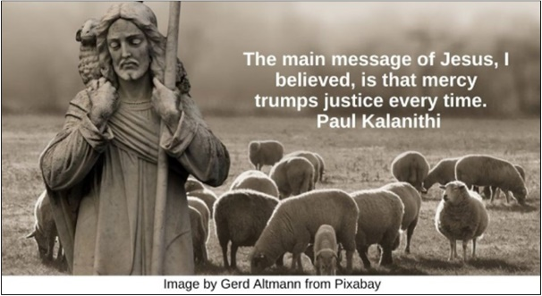

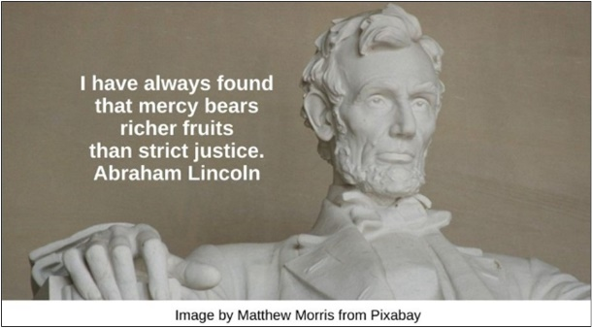

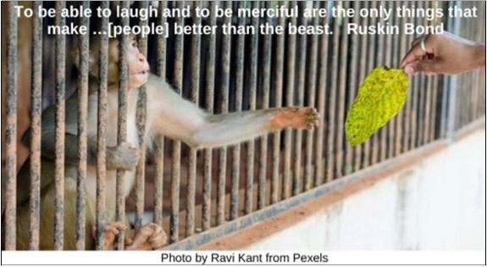

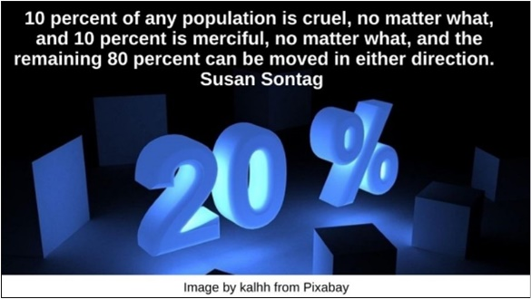



Resources for Children
2.0: Children’s Homilies, Sermons, Time for All Ages & Resources
No resources found

3.0: Wisdom Stories

3.1: The Good Samaritan (576 words)
One day a lawyer came to Jesus and asked what he needed to do to live forever or, "to get into heaven" or "to become enlightened."
Jesus asked him what the law of the Ten Commandments said. The lawyer answered, "You shall love God with all your heart, and with all of your soul, and with all your strength, and your neighbor as yourself." "Right!" said Jesus. Then the lawyer asked, "But, Teacher, who is my neighbor?" In other words, "who do I have to treat lovingly?" This is the story that Jesus told to the man:
Once, a man was walking on a lonely stretch of road between Jerusalem and Jericho. Suddenly a gang of thieves jumped out from the side of the road and surrounded him. "Give us your money," they demanded. "I need my money" he cried. "I have to buy food with this money, for myself and my whole family."
One of the thieves picked up a rock from the side of the road and hit the man in the head. He fell to the ground with a groan, bleeding. Seeing no one around the thieves jumped on the man and took everything he had, including his money, and his clothing. One of the thieves picked up a stick and hit the man hard several times before leaving him on the side of the road half dead.
After a time, a priest came walking down the road. He saw the man lying on the side of the road and crossed over to the other side as he hurried by.
Soon another man, a Levite appeared. He too, saw the wounded man lying in the hot sun, naked and bleeding and he scurried on by.
A long time passed. Flies buzzed around the man who was dying from his injuries. Luckily someone else was coming down the road. He was a Samaritan riding on his donkey. Now the people of Samaria were not friendly with the people of this man's country. They were sworn enemies of each other.
But the Samaritan man did not hesitate when he saw the man lying by the side of the road. He didn't stop to think about whether he should help him because of where he was from, or what group the man belonged to. He saw that this man needed help and he felt compassion.
The Samaritan took healing oil and wine from his bag and cleaned the man's wounds and bound them up with bandages made from the cloth of his own shirt. He covered him with a robe. He gave the man a drink of water and helped the man onto his donkey. Slowly, for the man was in great pain and the road was long, they walked to the next town. There the Samaritan found an inn and asked the innkeeper to give him what was necessary to make the man comfortable.
The next day, the Samaritan gave money to the innkeeper to pay for the wounded man to stay at the inn until he got better. The Samaritan promised to come back in a few days and pay whatever else was needed to bring the man back to health.
When Jesus finished telling this story, he asked the lawyer, “Which one of these three men acted like a neighbor to the man who fell among thieves?” The lawyer said, “The one who showed kindness.” “Yes,” said Jesus, “go and do the same.”

Source: https://www.uua.org/re/tapestry/children/tales/session8/123425.shtml

3.2: Jesus and the Sheep (582 words)
Excerpts from the New Revised Standard Version of the Bible.
Sheep were important in biblical times. They provided not just wool, but also meat and milk. Their horns were used as musical instruments or to hold oil. The skins were made into clothing and coverings for walls.
If you read the Bible today, you'll find that sheep and shepherds are mentioned many times. One person who counted says the Bible talks about sheep and shepherds 247 times.
The first part of the Bible, called the Hebrew scripture, includes a famous song called the twenty-third Psalm. It begins with these words: "The Lord is my shepherd; I shall not want. He makes me lie down in green pastures." In other words, people are like sheep, cared for by God.
The second part of the Bible is the Christian scripture. It tells about Jesus' life and teachings. In one famous story told by the disciple John, Jesus calls himself a shepherd. He says these famous words: "I am the good shepherd. The good shepherd lays down his life for the sheep. The hired hand, who is not the shepherd and does not own the sheep, sees the wolf coming and leaves the sheep and runs away—and the wolf snatches them and scatters them. The hired hand runs away because a hired hand does not care for the sheep. I am the good shepherd. I know my own and my own know me, just as the Father knows me and I know the Father. And I lay down my life for the sheep. I have other sheep that do not belong to this fold. I must bring them also, and they will listen to my voice. So there will be one flock, one shepherd."
Of course, when Jesus said "Father," he meant God. But it wasn't always easy to know exactly what Jesus meant. That is because he often taught by telling stories called parables. One of the best known is called "The Parable of the Lost Sheep." Here is the way the disciple Luke tells the story:
So, he told them this parable: "Which one of you, having a hundred sheep and losing one of them, does not leave the ninety-nine in the wilderness and go after the one that is lost until he finds it? When he has found it, he lays it on his shoulders and rejoices. And when he comes home, he calls together his friends and neighbors, saying to them, 'Rejoice with me, for I have found my sheep that was lost.' Just so, I tell you, there will be more joy in heaven over one sinner who repents than over ninety-nine righteous people who need no repentance." [Note: This is known as one of the mercy parables.]
Why is this story so important? There are two reasons. The first is that it helps people know the difference between right and wrong. When there is a problem, the story says, you should not go away and ignore it. You should actively try to fix it.
The second is that the story talks about God's [mercy and] forgiveness. If you do something wrong, that is bad. But if you repent, God will celebrate. Repenting means feeling badly about what you did. If you repent, you admit that you were wrong, you say you are sorry, and you find ways to make things better.
So, sheep in biblical times were good for more than meat, milk, wool, and skin. They and their shepherds were a big help to religious leaders and teachers who wanted people to know the difference between right and wrong.

Source: https://www.uua.org/re/tapestry/children/grace/session8/jesus

3.3: The Prodigal Son (aka the Lost Son) from Luke 15:11-32 (New Revised Standard Version) (514 words)
Then Jesus said, "There was a man who had two sons. The younger of them said to his father, 'Father, give me the share of the property that will belong to me.' So, he divided his property between them. A few days later the younger son gathered all he had and travelled to a distant country, and there he squandered his property in dissolute living. When he had spent everything, a severe famine took place throughout that country, and he began to be in need. So, he went and hired himself out to one of the citizens of that country, who sent him to his fields to feed the pigs. He would gladly have filled himself with the pods that the pigs were eating; and no one gave him anything. But when he came to himself, he said, 'How many of my father's hired hands have bread enough and to spare, but here I am dying of hunger! I will get up and go to my father, and I will say to him, "Father, I have sinned against heaven and before you; I am no longer worthy to be called your son; treat me like one of your hired hands."' So, he set off and went to his father. But while he was still far off, his father saw him and was filled with compassion; he ran and put his arms around him and kissed him. Then the son said to him, 'Father, I have sinned against heaven and before you; I am no longer worthy to be called your son.' But the father said to his slaves, 'Quickly, bring out a robe—the best one—and put it on him; put a ring on his finger and sandals on his feet. And get the fatted calf and kill it, and let us eat and celebrate; for this son of mine was dead and is alive again; he was lost and is found!' And they began to celebrate.
Now his elder son was in the field; and when he came and approached the house, he heard music and dancing. He called one of the slaves and asked what was going on. He replied, 'Your brother has come, and your father has killed the fatted calf, because he has got him back safe and sound.' Then he became angry and refused to go in. His father came out and began to plead with him. But he answered his father, 'Listen! For all these years I have been working like a slave for you, and I have never disobeyed your command; yet you have never given me even a young goat so that I might celebrate with my friends. But when this son of yours came back, who has devoured your property with prostitutes, you killed the fatted calf for him!' Then the father said to him, 'Son, you are always with me, and all that is mine is yours. But we had to celebrate and rejoice, because this brother of yours was dead and has come to life; he was lost and has been found.'"

Source: https://www.uua.org/re/tapestry/youth/virtueethics/workshop7/193748.shtml

3.4: The Pitcher of Tears by Megan McKenna (990 words)
“Once upon a time there was a good and faithful rabbi. The day of Yom Kippur came, and all day the rabbi had fasted, done penance, and prayed for his people, his small congregation. That night, the holiest night of the Jewish year, they were all gathered in the synagogue praying, asking for forgiveness and mercy from God, blessed by his Name. The rabbi stood with his back to the people, wrapped tightly in his prayer shawl, and prayed. He prayed as fervently and intensely as he could. He remembered that every synagogue around the world gathered the Jews together on this day and all their prayers were ascending to God, the Holy One.
“As he prayed, he begged God for some sign that his prayer on behalf of his people was heard. As soon as he thought it and prayed, he was taken aback. Why should the Holy One respond to such a prayer, when there were probably many others, hoping for the same thing? And yet, almost instantaneously, he was given an answer to his prayers. For such a moment he heard the voice of God, clear and ringing out like a bell: ‘Have Tam offer your prayers to me, and I will graciously accept all of you back into my heart, forgiving all things and showering my mercy upon you.’ And then, just as surely the light, the sense, the sound, was gone. The rabbi stood with his back to the people praying still, and he was alone.
“Then he turned and came toward the people. Instead of praying the prayer of intercessions as the ritual demanded, he called out: ‘Tam! Tam! Where is Tam?’ He knew what everyone was thinking — he had been thinking it himself for seconds before. Why Tam? Tam was hardly ever in the synagogue. He was poor, unlettered, and worked so hard that he often missed services. Oh, he was a good-hearted enough soul, but he certainly hadn’t amounted to much in the community. The rabbi didn’t even know exactly what Tam did for a living. The people were stunned, shocked.
“And poor Tam, who was in fact in the synagogue on this holy night, was equally stunned. He was paralyzed and could not move. Why did the rabbi call out his name instead of praying? What terrible thing was about to be visited upon him? But others in the synagogue recognized him, and the rabbi gestured to them to carry Tam forward to the front of the synagogue. Tam stood, silent, with head bowed before the rabbi.
“The rabbi spoke loudly and directly to Tam. ‘I have been praying for mercy and forgiveness for all of us on this night and I have been clearly told by God, blessed be his Name, that we all will be forgiven and taken back into the heart of God if you pray for us, if you give your prayer to God on our behalf.’
“Tam was speechless. How could he pray? He could not even read the service, the prayers in the book. But the rabbi was insistent. God would only take the community back into his heart and give them a year of blessing, grace, and mercy if Tam prayed for them. He had to pray for them! Finally, Tam agreed. But he looked at the rabbi and said: ‘I have to go get my prayers.’
“What? The rabbi thought. You have to go get your prayers? ‘Then go,’ he said.
“Tam ran down the aisle, pushing people aside. Everyone was in confusion and disarray. But Tam did not live far, just down a side street away from the synagogue’s back door. He was back in no time.
“Once again there was tumult in the synagogue as Tam returned to the front to stand beside the rabbi and pray on behalf of the community. He stood before them all, and in his hands was a large earthen pitcher. He lifted it high, turned his back on the people, and addressed God. ‘O Holy One, you know I am not good at praying, but I bring you all I have. This pitcher holds my tears. Late at night, even when I am tired, I sit and try to pray to you. And then I think of my poor wife and children and the fact that they have no clean clothes to wear to service and are ashamed to come to the synagogue, and I cry. And then I think of all the hungry ones, the beggars on the steps of the synagogue and in the streets, in the cold and rain, miserable and so alone, and I cry some more. And then, God, I think of what we do to each other. I think of all the gossip and hate, all the quarrels and wars, and I think of you crying, God, of you looking down on us hurting one another so, and I know that you weep for us always. God, I cry for you and how we must break your heart and sadden you so. Please, take my tears, accept my prayers, and take all of us back into your heart once again. Give us a blessing and forgive us in your great mercy and kindness.’
“And Tam took the pitcher and poured his tears over the floor of the synagogue. There was a long silence, and then the rabbi spoke haltingly: ‘God has heard Tam, and we are forgiven. We are once again the people of God. Let us live this year with grateful hearts.’
“The people sang, but they left the synagogue quietly. They vowed never to forget Tam’s prayer or his pitcher of tears and to make sure there would be less to cry over in the years to come. They looked at Tam and his family differently, and their neighbors too. Some even reconciled with their enemies. But they all went home thinking of the tears of God.”
Source: https://www.spiritualityandpractice.com/book-reviews/excerpts/view/15056/lent

3.5: The Woman Who Outshone the Sun: The Legend of Lucia Zenteno by Nancy Jilk (1,058 words)
Characters
- Narrator
- Lucia Zenteno (older child or adult)
- Iguana (small child)
- Water (several)
- Fish (several)
- Otters (several)
- Townspeople-elders and children (several)
Props
- Long, flowing, bright skirt with pinned on flowers and butterflies; long black hair (crown with black streamers or fabric strips); simple costumes to indicate water, fish, otters; makeshift cave; rain sticks.
Narrator: Today the children of our church will perform a story called “The Woman Who Outshone the Sun.” This tale is part of the oral history of the Zapotec Indians of Oaxaca, Mexico.
It was adapted from a poem written by Alejandro Cruz Martinez, a young Zapotec poet. Martinez was killed in 1987 while organizing his people to regain their lost water rights.
Hymn #305, “De colores” (from Singing the Living Tradition)
[TOWNSPEOPLE ENTER SINGING DOWN SIDE AISLE. LUCIA AND IGUANA LEAD PROCESSION OF WATER, FISH, OTTERS DOWN CENTER AISLE.]
Narrator: The day Lucia Zenteno arrived, everyone in the village was astonished. No one knew where she came from. Yet they all saw that she was amazingly beautiful and that she brought thousands of dancing butterflies and brightly colored flowers on her skirts. She walked softly yet with a quiet dignity, her long, unbraided hair flowing behind her. A loyal iguana walked at her side.
[LUCIA, IGUANA, WATER, FISH, AND OTTERS GATHER ON STAGE.]
Narrator: No one knew who she was, but they did know that nothing shone as brightly as Lucia Zenteno. Some people said that Lucia Zenteno outshone the sun. Others said that her glorious hair seemed to block out the light. Everyone felt a little afraid of someone so wonderful and yet so strange.
There used to be a river that ran by the town, almost the same river that runs by there now.
[WATER MOVES ABOUT STAGE.]
Narrator: And people said that when Lucia Zenteno went there to bathe, the river fell in love with her. The water rose from its bed and began to flow through her shining black hair.
[WATER MOVES BEHIND/UNDER LUCIA ‘S HAIR.]
Narrator: Fish jumped and swam, while otters dove and slithered.
[WATER, FISH, AND OTTERS DANCE AND PLAY ON STAGE.]
Narrator: When Lucia finished bathing, she would sit by the river and comb out her hair with a comb made from the wood of the mesquite tree. And when she did, the water, the fishes, and the otters would flow out of her hair and return to the river once more.
The old people of the village said, that although Lucia was different from them, she should be honored and treated with respect.
Elder: You should respect Lucia because she understands the ways of nature.
Narrator: But some people did not listen to the elders. They were afraid of Lucia’s powers, which they did not understand. And so, they refused to answer Lucia’s greetings, or offer her their friendship. They spied on her day and night. They even made up a cruel chant.
Townspeople: Lucia plays with otters! Lucia smells like fish heads!
[TOWNSPEOPLE LAUGH DERISIVELY AND POINT FINGERS.]
Narrator: Lucia did not return the meanness of the people. She kept to herself and continued to walk with her head held high. Her quiet dignity angered some of the people. They whispered that Lucia must be trying to harm them.
People became more afraid of Lucia and so they treated her more cruelly. They continued their chant, even louder than before.
Townspeople: [LOUDER THAN BEFORE] Lucia plays with otters! Lucia smells like fish heads!
Narrator: Finally, they drove her from the village.
LUCIA AND IGUANA LEAVE STAGE SLOWLY AND SADLY]
Narrator: Lucia went down to the river one last time to say good-bye. As always, the water rose to greet her and began to flow through her glorious hair.
[WATER, FISH, OTTERS DANCE AROUND LUCIA.]
Narrator: But this time when she tried to comb the river out of her hair, the river would not leave her. And so, when Lucia Zenteno left the village, the river and the fishes and the otters went with her, leaving only a dry, winding riverbed, a serpent of sand where the water had been.
[LUCIA, IGUANA, WATER, FISH, AND OTTERS LEAVE AND HIDE IN CAVE.]
Narrator: Everyone saw that Lucia Zenteno was leaving and that the river, the fishes, and the otters were leaving with her. The people were filled with despair. They had never imagined that their beautiful river would ever leave them, no matter what they did.
Where once there had been green trees and cool breezes, now no more rain fell, no birds sang, no otters played. The people and their animals suffered from thirst. People began to understand, as never before, how much the river, the fishes, the otters, even the trees and birds had meant to the village. They began to understand how much the river had loved Lucia Zenteno.
The elders said that everyone must search for Lucia and beg her forgiveness.
Elder: Don’t you see? We must apologize for treating her so cruelly!
Narrator: Some people did not want to. But when the drought continued, everyone finally agreed to follow the elders’ advice. And so the whole village set out in search of Lucia.
[TOWNSPEOPLE LOOK AROUND FOR LUCIA.]
Narrator: After many days of walking, the people found the iguana cave where Lucia had gone to seek refuge. Lucia was waiting for them, but they could not see her face. She had turned her back to the people.
At first no one dared say a word. Then two children called out:
Children 1 and 2: Lucia, we ask your forgiveness. Have mercy upon us and return our river!
Narrator: There was no reply, so one of the townspeople called out:
Townsperson: Lucia, we ask your forgiveness. Have mercy upon us and return our river!
Narrator: Alas, there was no reply.
[NARRATOR DIRECTS CONGREGATION TO JOIN IN THE CHANT.]
Congregation: Lucia, we ask your forgiveness. Have mercy upon us and return our river!
Narrator: Lucia Zenteno turned and looked at the people. She saw their frightened, tired faces, and she felt compassion for them. At last, she asked the river to return to the people. Lucia told them that, just as the river gives water to all who are thirsty, no matter who they are, they must treat everyone with kindness, even those who seem different.
The people remembered how they had treated Lucia, and they hung their heads in shame.
Narrator: Seeing that the people were truly sorry for what they had done, Lucia returned with them to the village and began to comb out her hair.
[LUCIA, WATER, FISH, AND OTTERS RETURN TO STAGE.]
Narrator: She combed out the water, she combed out the fishes, she combed out the otters, and she kept on combing until the river had returned once more to where it belonged. The people were overjoyed to have their river again. They poured water over themselves and over their animals, they jumped into the river, and they laughed and cried with happiness.
Hymn #100, “I’ve Got Peace Like a River” (from Singing the Living Tradition)
[LUCIA AND IGUANA SNEAK OUT WHILE CONGREGATION IS SINGING.]
Narrator: In all the excitement, no one noticed at first that Lucia had disappeared again. But soon the children began to ask questions.
Child 1: Where did she go?
Child 2: Where can she be?
Narrator: The elders replied that Lucia had not really left them. Though they would not be able to see her, she would always be there, guiding and protecting them, helping them to live with love and understanding in their hearts.
At long last, the skies opened, the rain came down and blessed the town.
Rain sticks used
THE END
Source: https://www.uua.org/worship/words/story/108211.shtml

4.0: Children’s Books about Works of Mercy

Works of Mercy

To feed the hungry

4.1: Maddi's Fridge by Lois Brandt, author and Vin Vogel, illustrator (2014)

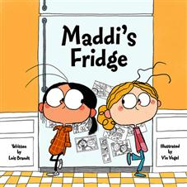
“Best friends Sofia and Maddi live in the same neighborhood, go to the same school, and play in the same park, but while Sofia’s fridge at home is full of nutritious food, the fridge at Maddi’s house is empty. Sofia learns that Maddi’s family doesn’t have enough money to fill their fridge and promises Maddi she’ll keep this discovery a secret. But because Sofia wants to help her friend, she’s faced with a difficult decision: to keep her promise or tell her parents about Maddi’s empty fridge. Filled with colorful artwork, this storybook addresses issues of poverty with honesty and sensitivity while instilling important lessons in friendship, empathy, trust, and helping others. A call-to-action section, with six effective ways for children to help fight hunger and information on antihunger groups, is also included.”

Video Link: https://www.youtube.com/watch?v=Iy9nP5Xqv1M (8:20)

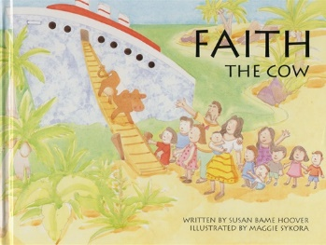
4.2: Faith the Cow by Susan Bame Hoover, author and Maggie Sykora, illustrator (1995)

“Captivating story of the first animal sent overseas through Heifer Project International.”

Video Link: https://vimeo.com/437675287 (7:35)

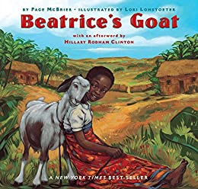
4.3: Beatrice's Goat by Page McBrier, author and Lori Lohstoeter, illustrator (2004)

“This illustrated book offers the true story of how a poor African girl was able to attend school after receiving a goat as a gift through a special international project and then sell its milk to get the money needed to buy her books.”

Video Link: https://www.youtube.com/watch?v=dYQMdv-QFPI (9:09)


4.4: Tight Times by Barbara Shook Hazen, author and Trina Schart Hyman, illustrator (1979)

“A small boy, not allowed to have a dog because times are tight, finds a starving kitten in a trash can on the same day his father loses his job.”

Video Link: https://www.youtube.com/watch?v=iZscds0e0xo (5:22)

4.5: The Last Stop on Market Street by Matt de la Peña, author and Christian Robinson, illustrator (2015)
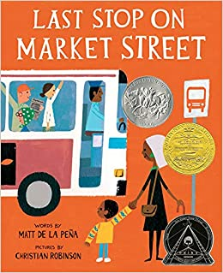
“A boy and his grandma catch the bus. We don’t yet know where they are headed, but along the way the boy asks questions about why they don’t have certain luxuries. He wants to know why they don’t have a car or an ipod. The grandma has a ready answer about the advantages of what they do have and encourages him to think of positive aspects of lacking material goods. When they reach their destination, we find out that they were traveling to help out at a soup kitchen.”
Video Link: https://www.youtube.com/watch?v=QoPS0Ok5YiI (10:43)

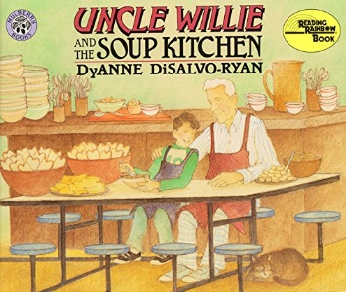
4.6: Uncle Willie and the Soup Kitchen by Dyanne Disalvo-Ryan, author (1997)

“Based on the actual volunteer experience of the author, this picture book provides a look into the soup kitchen without an overly sentimental view of the hungry or a dose of pessimism for the reader. With a note about soup kitchens introducing the story, this is informative and new, but not scary,” praised Booklist.
“A boy wonders about the people he sees on his city’s streets until he goes to the soup kitchen where his uncle works. The varied needs of the individuals there become clear to the young narrator. The watercolors use earth tones and careful detail to illustrate aptly the warm, friendly story," according to The Horn Book.

Video Link: https://www.youtube.com/watch?v=UAy0vvY6duk (15:03)

4.7: An Orange for Frankie by Patricia Polacco (2004)

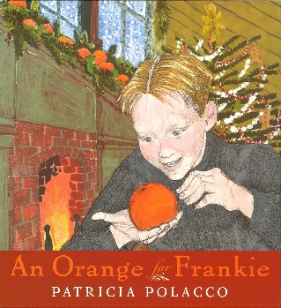
“The Stowell family is abuzz with holiday excitement, and Frankie, the youngest boy, is the most excited of all. But there's a cloud over the joyous season: Tomorrow is Christmas Eve, and Pa hasn't returned yet from his trip to Lansing. He promised to bring back the oranges for the mantelpiece. Every year there are nine of them nestled among the evergreens, one for each of the children. But this year, heavy snows might mean no oranges . . . and, worse, no Pa!
“This is a holiday story close to Patricia Polacco's heart. Frankie was her grandmother's youngest brother, and every year she and her family remember this tale of a little boy who learned--and taught--an important lesson about giving, one Christmas long ago.”

Video Link: https://www.youtube.com/watch?v=EkeC51k-FtI (21:48)

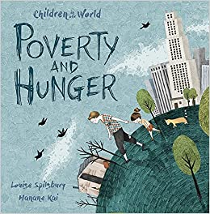
4.8: Poverty and Hunger by Louise Spilsbury, author and Hanane Kai, illustrator (Children in Our World Series) (2017) (hunger and poverty)

Poverty and Hunger discusses the questions "What is poverty and hunger? How do they affect people in countries all over the world?" It helps children begin to understand the way others struggle with these issues and learn about ways they can help.

Video Link: https://www.youtube.com/watch?v=1BnTzUHSQSk (8:59)

4.9: How Can We Help the Hungry handout

https://static1.squarespace.com/static/536fe0f6e4b08758c320b79a/t/580d552446c3c40d23a6e359/1477268774143/Hungry+PDF.pdf

To give water to the thirsty

4.10: The Water Princess by Susan Verde and Georgie Badiel, authors and Peter H. Reynolds, illustrator
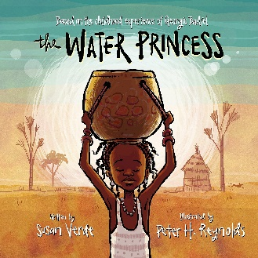
“In an African village, a mother and daughter, Gie Gie, must walk miles to bring back water, starting before sunrise. The water, when they finally get it, is cloudy with dirt. With this water, they wash clothes, prepare food for cooking, and boil for drinking. After waiting all day, Gie Gie finally gets water to drink. This journey must be done every day until someday when clear, clean water will miraculously flow in their village. This is Princess Gie Gie’s dream! The back matter notes that nearly one billion people around the world don’t have access to clean water. African model Georgie Badiel is working to change this.”

Video Link: https://www.youtube.com/watch?v=NEs7xQZMA9M (6:56)

4.11: Anna Carries Water by Olive Senior, author and Laura James, illustrator (2014)
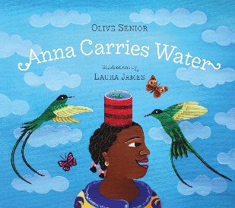
“Anna wants to carry water on her head like her siblings, but she’s the youngest and it spills. Every evening after school, the kids went to the spring for water and carried it back home. The water is used for cooking, drinking, washing dishes and faces, and brushing teeth. They go to the river to wash clothes and bathe. This story focuses on Anna learning to carry water and overcome her fear of the neighbor’s cows, but it is also useful to contrast to other areas where water is further away and the impact of that on the children.”
Video Link: https://www.youtube.com/watch?v=BrURleaDxUk (5:51)

4.12: The Water Walker by Joanne Robertson (2017)

“The determined story of an Ojibwe grandmother (nokomis), Josephine Mandamin, and her great love for nibi (water). Nokomis walks to raise awareness of our need to protect nibi for future generations and for all life on the planet. She, along with other women, men and youth, has walked around all the Great Lakes from the four salt waters, or oceans, to Lake Superior. The walks are full of challenges, and by her example she challenges us all to take up our responsibility to protect our water, the giver of life, and to protect our planet for all generations.”
“Gichi miigwech, Nibi, for the life you give to every living thing on Earth. I love you. I respect you.
“She walked, with other activists, around all of the Great Lakes, wearing out eleven pairs of sneakers.
Video Link: https://www.facebook.com/Ojibiikaan/videos/the-water-walker-by-joanne-robertson/279321199744721/ (15:17)

4.13: Water by Subhash Vyam (2018)
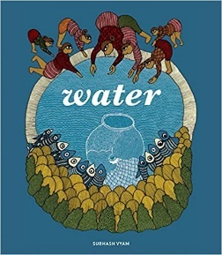
“Weaving his tale around a Gond fable about water, artist Subash Vyam muses on the history of our relationship to this most primeval of elements. A migrant to the city, he recalls growing up in a village where water was always scarce and human ingenuity was welcomed. In contrast to the village, the needs of the city are monstrous and there is a great danger that we will run this resource completely dry. In the end, there is only one way forward: all communities need to make a pact with Nature in order to survive ― or in our mindless push to harness her powers, we might lose our own place in this universe. )(ages 12 and up)

Link: https://www.brainpickings.org/2018/08/29/water-subhash-vyam/ (extensive overview of the book with illustrations)

4.14: Water’s Children: Celebrating the Resource that Unites Us All by Angèle Delaunois, author, Gérard Frischeteau, illustrator and by Erin Woods, translator
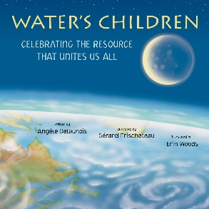
“Around the world, water appears in many forms: a snowflake, an oasis, the stream from a faucet, monsoon rain. In Water's Children, twelve young people describe what water means to them. The descriptions are as varied as the landscapes the speakers inhabit, but each of them also expresses, in their own language, a universal truth: Water is life.”

Video Link: https://www.youtube.com/watch?v=fAtwuyxKn7Q (4:59)


4.15: A Cool Drink of Water by Barbara Kerley (2002)
“An Italian boy sips from a fountain in the town square. A hiker takes
a refreshing drink from a mountain stream. Black-robed women in India stride gracefully through a field with brass water jugs balanced on their heads. Whether they squeeze it out of a burlap bag, haul it home from a communal tap, or get it out of their kitchen faucet, people all around the world are unified by their common need for water.”
“National Geographic photographs portray how people around the world collect and drink water. With very simple text, this is the perfect picture book to show a multicultural view of what it is like to get a drink of water. The photographs are detailed in the back matter both with location and how the water is procured. The final page is about water conservation. It’s easy to take fresh water for granted…..”

Video Link: https://www.youtube.com/watch?v=-WYlviGvZYA (5:04)

To clothe the naked
4.16: Coat of Many Colors by Dolly Parton, author and Brooke Boynton Hughes illustrator (2016)
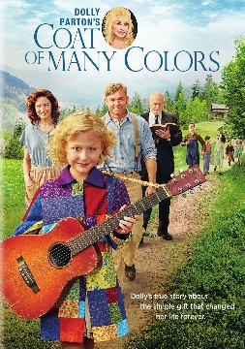
Country music legend Dolly Parton’s rural upbringing in the Smoky Mountains of Tennessee provides the backdrop for this special picture book. Using lyrics from her classic song “Coat of Many Colors,” the book tells the story of a young girl in need of a warm winter coat. When her mother sews her a coat made of rags, the girl is mocked by classmates for being poor. But Parton’s trademark positivity carries through to the end as the girl realizes that her coat was made with love ‘in every stitch.’”

Video Link: https://www.youtube.com/watch?v=jADgHWYT9r8 (3:45)

4.17: The Rag Coat by Lauren A. Mills, author (1991)

“Before Minna can go to school, she needs a winter coat. The Quilting Mothers offer to make her a coat from scraps of quilting cloth, and Minna carefully chooses the pieces that have the best stories behind them.”

Video Link: https://www.youtube.com/watch?v=zQ0QJIsnNeA (12:41)

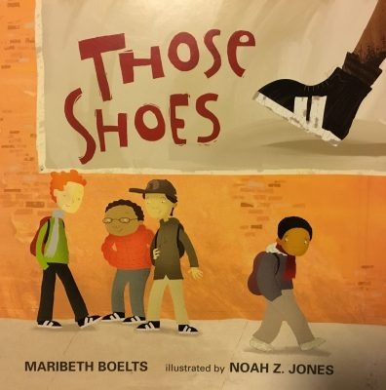
4.18: Those Shoes by Maribeth Boelts, author and Noah Z. Jones, illustrator (2009)
“This book deals well with the topic of poverty and the importance of putting others’ needs ahead of our own wants. Jeremy wants the latest pair of trendy shoes. All his friends have them but his grandmother can’t afford to buy him a pair. I like that she never shamed him for wanting what he couldn’t have. Jeremy finds a pair at a thrift store and buys them even though they are too small. When he makes friend with a kid at school who needs them more than he does, he gives them to him. I love how this book is honest about the struggles Jeremy has about giving the shoes away. He really wants to keep them for himself but in the end does the right thing on his own. Jeremy feels embarrassed about the shoes he does have to wear and that doesn’t disappear, making the act of kindness even more powerful.”

Video Link: https://www.youtube.com/watch?v=JfcT7IO2STw (2:24)

4.19: Sam and the Lucky Money by Karen Chinn, author and Cornelius Van Wright & Ying-Hwa Hu, illustrators (1995)

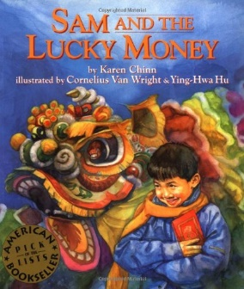
Sam is excited to be able to spend his lucky New Year money. He has four dollars and his mom has told him he can buy anything he wants. On their trip through the neighborhood Sam notices a homeless man with bare feet. As he contemplates how to spend his money, he gets frustrated that the four dollars is never enough to buy what he wants. His mother reminds him to appreciate what he has. During a second encounter with the homeless man, Sam understands how he can best spend his money.

Video Link: https://www.youtube.com/watch?v=nzsvSrtns9g (8:04)

4.20: The Hundred Dresses by Eleanor Estes, author and Louis Slobodkin, illustrator (1944/2004)

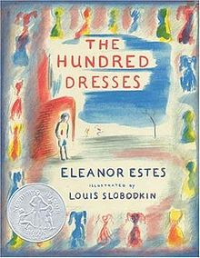
“Wanda Petronski is ridiculed by her classmates for wearing the same faded blue dress every day. She claims she has one hundred dresses at home, but everyone knows she doesn’t. When Wanda is pulled out of school one day, the class feels terrible, and classmate Maddie decides that she is ‘never going to stand by and say nothing again.’ A gentle tale about bullies, bystanders, and having the courage to speak up.”

This is a short novel; however, the two video adaptations retell the story in brief, meaningful ways. The first is a retelling using simple crayon drawings. The second is an enactment.

Video Link #1: https://www.youtube.com/watch?v=kzqGm61pY0Y (5:56)

Video Link #2: https://www.youtube.com/watch?v=Xv5Nzv0hWQE (8:23)

4.21: Four Feet, Two Sandals by Karen Lynn Williams & Khadra Mohammed, authors and Doug Chayka (2007)

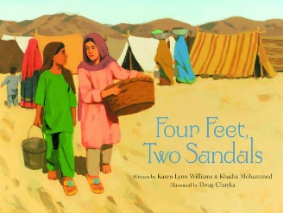
“When relief workers bring used clothing to the refugee camp, everyone scrambles to grab whatever they can. Ten-year-old Lina is thrilled when she finds a sandal that fits her foot perfectly, until she sees that another girl has the matching shoe. But soon Lina and Feroza meet and decide that it is better to share the sandals than for each to wear only one.”

Video Link: https://www.youtube.com/watch?v=VraJGkdgPF4 (7:43)

To shelter the homeless
4.22: A Shelter in Our Car by Monica Gunning, author, and Elaine Pedlar, illustrator (2013)
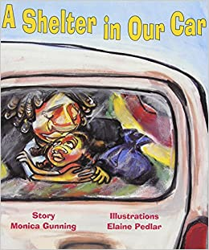
“Zettie and her Mama left their warm and comfortable home in Jamaica for an uncertain life in the United Sates. With Papa gone, Mama can't find a steady job that will sustain them and so they are forced to live in their car. But Mama's unwavering love, support, and gutsy determination give Zettie the confidence that, together, she and her mother can meet all challenges. Monica Gunning's moving and authentic story about homelessness in an American city was developed with the help of the Homeless Children s Network in San Francisco.”
Video Link: https://www.youtube.com/watch?v=RYAFaZwNTtg (14:40)

4.23: The Lady in the Box by Ann McGovern, author, and Marni Backer, illustrator (1997)
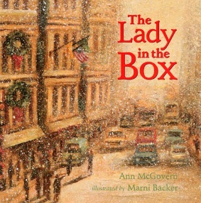
“It is wintertime in the city and freezing cold, but not everyone is inside and warm. Ben and his sister Lizzie know that there is a lady who lives outside in a box over a warm air vent. The children worry about the kind-looking lady, and begin sneaking food and clothes out of their apartment for her. Gently told and powerfully illustrated in rich hues, The Lady in the Box deals candidly with the issue of homelessness.”
Video Link: https://www.youtube.com/watch?v=i6R8_MkY58M (7:01)

4.24: A Place to Stay: A Shelter Story by Erin Gunti, author and Estelí Meza, illustrator (20:19)
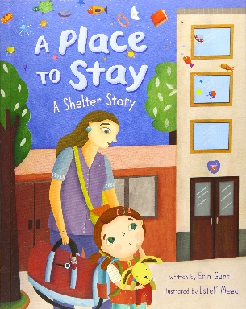
“When a little girl and her mother arrive at a women’s shelter, the child is sure she doesn’t want to stay there. Her mother uses the power of imagination to transform the activity room of the shelter into a treasure cave. The squeaky bed becomes a rocket ship that can send her right to the stars. Her mother’s encouragement eventually allows the little girl to let down her guard a bit and get to know one of the other families at the shelter.
“After the story, there are two pages of illustrated educational notes that help children understand the different reasons that people may be homeless, and how shelters can assist them.”
Video Link: https://www.pbs.org/video/place-stay-shelter-story-english-captions-gflol4/ (12:46)


4.25: The Teddy Bear by David McPhail (2002)
A young boy accidentally leaves his beloved teddy bear while out for the day. Understandably upset to have lost his stuffed friend, he looks for it only to discover it has been found and affectionately adopted by a homeless man. The boy’s empathy wins out and he decides to allow the man to keep the bear.
Video Link: https://www.youtube.com/watch?v=q9mcfeFZPQc (5:16)

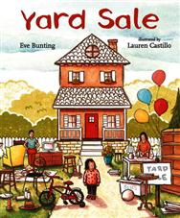
4.26: Yard Sale by Eve Bunting, author, and Lauren Castillo, illustrator (2015)
A young narrator describes the day her family has a yard sale in order to downsize their material possessions before their move to a much smaller apartment. Callie feels sad at the loss of the items, even though she knows that her family can no longer afford to live in the large house. Her parents help her understand that they are still a loving family and that moving is the next adventure, even if it means having doing without.
Video Link: https://www.youtube.com/watch?v=uTcq-2FRQ6w (5:29)

4.27: The Butterfly by Patricia Polacco (2000)

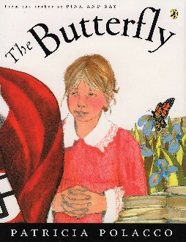
“Since the Tall Boots--the Nazis--have marched into Monique's small French village, terrorizing it, nothing surprises her. Until the night Monique encounters ‘the little ghost’ sitting at the end of her bed. When she turns out to be—not a ghost at all—but a young girl named Sevrine, who has been hiding from the Nazis in Monique's own basement, how could Monique not be surprised! Playing upstairs after dark, the two become friends until, in a terrifying moment, they are discovered, sending both of their families into a nighttime flight. In the tradition of Pink and Say, Patricia Polacco once again dips into her own family's history to reveal her Aunt Monique's true story of friendship from the French Resistance.

Video Link: https://www.youtube.com/watch?v=nvJ0niQxOso (23:21)

To visit the sick
4.28: A Sick Day for Amos McGee by Philip C. Stead, author and Erin E. Stead, illustrator (2011)
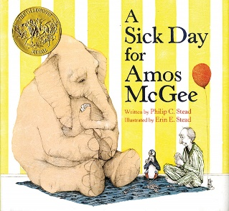
“Friends come in all sorts of shapes and sizes. In Amos McGee’s case, all sorts of species, too! Every day he spends a little bit of time with each of his friends at the zoo, running races with the tortoise, keeping the shy penguin company, and even reading bedtime stories to the owl. But when Amos is too sick to make it to the zoo, his animal friends decide it’s time they returned the favor.”
Video Link: https://www.youtube.com/watch?v=Lzrc-5apZ74 (5:07)

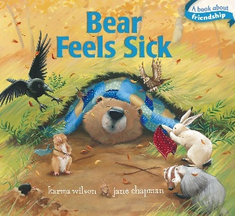
4.29: Bear Feels Sick by Karma Wilson, author and Jane Chapman, illustrator (2007)
“Sweet Bear isn’t feeling well at all. He is achy, sneezy, wheezy, and just plain sick! He’s in no shape to go outside to play. So, Mole, Hare, Mouse, and the rest of the gang try to make Bear feel as comfortable as possible in his cave. Bear starts to get better—but as soon as Bear is well, all of his friends get sick!”

Video Link: https://www.youtube.com/watch?v=oVHRDXRdrbo (4:37)

4.30: How Do You Care for a Very Sick Bear? by Vanessa Bayer, author and Rosie Butcher, illustrator (2019)
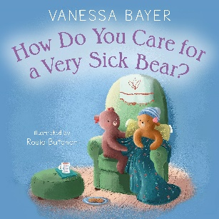
“When someone dear is dealing with illness, it's difficult to know what to do or say. The actor Vanessa Bayer experienced this firsthand when she was treated for childhood leukemia. In her first children's book, she offers gentle, reassuring advice that people of all ages will appreciate.”

Video Link: https://www.youtube.com/watch?v=B_UJ-JpY6Ok (4:12)
Slide Show: https://us.macmillan.com/books/9781250298430 (showing 12 of 32 pages)

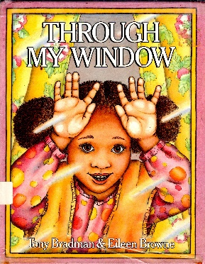
4.31: Through My Window by Tony Bradman, author & Eileen Browne, illustrator (1986)
“This special edition commemorates the 30th anniversary of this classic multicultural picture book. Jo is ill and has to stay in bed for the day, but her mum promises to bring her home a surprise to make her feel better. All day long Jo looks out of the window waiting for her mum to return, and in the meantime sees all her friends from the neighborhood, including the postman, the window cleaner and Mrs. Ali from next door. But when will Mum be back with her surprise for Jo?”
Video Link: https://www.youtube.com/watch?v=xB5VJ9W_qmI (3:27)

4.32: The Lemonade Club by Patricia Polacco (2007)
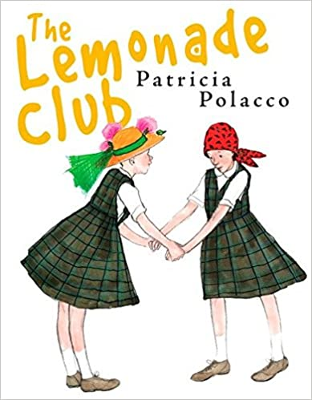
“Everyone loves Miss Wichelman?s fifth-grade class—especially best friends Traci and Marilyn. That's where they learn that when life hands you lemons, make lemonade! They are having a great year until Traci begins to notice some changes in Marilyn. She's losing weight, and seems tired all the time. She has leukemia—and a tough road of chemotherapy ahead. It is not only Traci and Miss Wichelman who stand up for her, but in a surprising and unexpected turn, the whole fifth-grade class, who figures out a way to say we're with you.”
Video Link: https://www.youtube.com/watch?v=pxMV3OSU3ys (20:29)

4.33: The Remember Balloons by Jessie Oliveros, author and Dana Wulfekotte, illustrator (2018)

James’s Grandpa has the best balloons because he has the best memories. He has balloons showing Dad when he was young and Grandma when they were married. Grandpa has balloons about camping and Aunt Nelle’s poor cow. Grandpa also has a silver balloon filled with the memory of a fishing trip he and James took together.
But when Grandpa’s balloons begin to float away, James is heartbroken. No matter how hard he runs, James can’t catch them. One day, Grandpa lets go of the silver balloon—and he doesn’t even notice!
Grandpa no longer has balloons of his own. But James has many more than before. It’s up to him to share those balloons, one by one.

Video Link: https://www.youtube.com/watch?v=AvvFJgu3tFs (6:15)

To visit the imprisoned, or ransom the captive
4.34: Mama’s Nightingale by Edwidge Danticat, author and Leslie Staub, illustrator (2015)
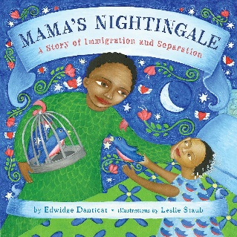
“After Saya’s mother is sent to an immigration detention center, Saya finds comfort in listening to her mother’s warm greeting on their answering machine. To ease the distance between them while she’s in jail, Mama begins sending Saya bedtime stories inspired by Haitian folklore on cassette tape. Moved by her mother’s tales and her father’s attempts to reunite their family, Saya writes a story of her own—one that just might bring her mother home for good.
“With stirring illustrations, this tender tale shows the human side of immigration and imprisonment—and shows how every child has the power to make a difference.”

Video Link: https://www.youtube.com/watch?v=SOb0qeR2CvA (9:02)

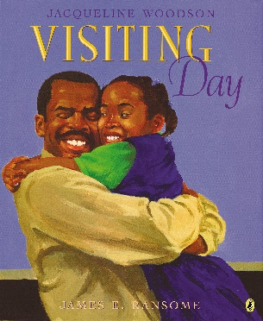
4.35: Visiting Day by Jacqueline Woodson, author and James Ransome, illustrator (2015)
“In this moving picture book from multi-award-winning author Jacqueline Woodson, a young girl and her grandmother prepare for a very special day—the one day a month they get to visit the girl's father in prison. ‘Only on visiting day is there chicken frying in the kitchen at 6 am and Grandma in her Sunday dress, humming soft and low.’ As the little girl and her grandmother get ready, her father, who adores her, is getting ready, too, and readers get to join the community of families who make the trip together, as well as the triumphant reunion between father and child.”

Video Link: https://www.youtube.com/watch?v=DooJoXT0YaY (5:59)


4.36: Mango Moon by Diane de Anda, author and Sue Cornelison, illustrator) (2019)
“When a father is taken away from his family and faces deportation, the family is left to grieve and wonder what comes next. Maricela, Manuel, and their mother face the many challenges of having their lives completely changed by the absence of their father and husband. Having to move, missed soccer games and birthday parties, and emptiness are just part of the now day-to-day norm. Mango Moon shows what life is like from a child’s perspective when a parent is deported, and the heartbreaking realities the family has to face.”

Video Link: https://www.youtube.com/watch?v=DkB5Goi7S_s (4:41)

4.37: The Night Dad Went to Jail: What to Expect When Someone You Love Goes to Jail by Melissa Higgins, author and Wednesday Kirwan, illustrator (2013)

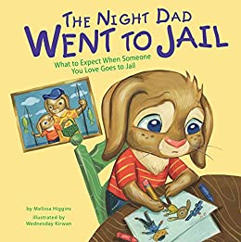
“When someone you love goes to jail, you might feel lost, scared, and even mad. This colorfully illustrated book lets children know that they are not alone in this situation. It offers age-appropriate explanations to help with difficult conversations. Told from the experience of a rabbit, this picture book is intended to make a parent's incarceration a little less frightening.”

Video Link: https://www.youtube.com/watch?v=Y6HG2tVccGE (6:34)

To bury [and mourn] the dead

4.38: Nana Upstairs & Nana Downstairs by Tomie DePaola (1997)

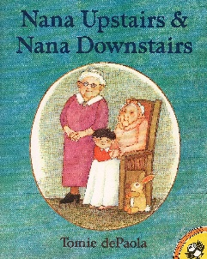
“Tommy is four years old, and he loves visiting the home of his grandmother, Nana Downstairs, and his great-grandmother, Nana Upstairs. But one day Tommy's mother tells him Nana Upstairs won't be there anymore, and Tommy must struggle with saying good-bye to someone he loves.”

Video Link: https://www.youtube.com/watch?v=x9niikNBh0I (5:05)

4.39: Ida, Always by Caron Levis, author and Charles Santoso, illustrator (2016)

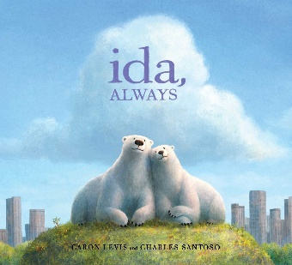
“A beautiful, honest portrait of loss and deep friendship told through the story of two iconic polar bears. Gus lives in a big park in the middle of an even bigger city, and he spends his days with Ida. Ida is right there. Always. Then one sad day, Gus learns that Ida is very sick, and she isn’t going to get better. The friends help each other face the difficult news with whispers, sniffles, cuddles, and even laughs. Slowly Gus realizes that even after Ida is gone, she will still be with him—through the sounds of their city, and the memories that live in their favorite spots.

Video Link: https://www.youtube.com/watch?v=Lcr_2ZnqQJE&feature=emb_logo (9:38)

4.40: The Invisible String by Patrice Karst, author and Geoff Stevenson, illustrator (2000)
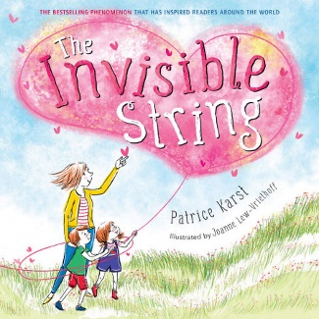
“‘That's impossible’, said twins Jeremy & Liza after their Mom told them they're all connected by this thing called an Invisible String. ‘What kind of string’? They asked with a puzzled look to which Mom replied, ‘An Invisible String made of love.’ That's where the story begins. A story that teaches of the tie that really binds. The Invisible String reaches from heart to heart. Does everybody have an Invisible String? How far does it reach, anyway? Does it ever go away? Read all about it! THE INVISIBLE STRING is a very simple approach to overcoming the fear of loneliness or separation with an imaginative flair that children can easily identify with and remember. Here is a warm and delightful lesson teaching young and old that we aren't ever really alone and reminding children (and adults!) that when we are loved beyond anything we can imagine. ‘People who love each other are always connected by a very special String, made of love. Even though you can't see it with your eyes, you can feel it deep in your heart, and know that you are always connected to the ones you love.’”

Video Link: https://www.youtube.com/watch?v=_cO2LBBBtAI (4:14)

4.41: The Goodbye Book by Todd Parr (2015)

… “A poignant and reassuring story about loss. Through the lens of a pet fish who has lost his companion, Todd Parr tells a moving and wholly accessible story about saying goodbye. Touching upon the host of emotions children experience, Todd reminds readers that it’s okay not to know all the answers, and that someone will always be there to support them. An invaluable resource for life’s toughest moments.:

Video Link: https://www.youtube.com/watch?v=brSBz_pSOZw (2:22)

4.42: The Memory Box: A Book About Grief by Joanna Rowland, author and Thea Baker, illustrator (2017)
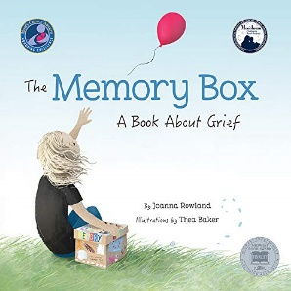
“‘I’m scared I’ll forget you...’ From the perspective of a young child, Joanna Rowland artfully describes what it is like to remember and grieve a loved one who has died. The child in the story creates a memory box to keep mementos and written memories of the loved one, to help in the grieving process. Heartfelt and comforting, The Memory Box will help children and adults talk about this very difficult topic together. The unique point of view allows the reader to imagine the loss of any they have loved - a friend, family member, or even a pet. A parent guide in the back includes information on helping children manage the complex and difficult emotions they feel when they lose someone they love, as well as suggestions on how to create their own memory box.”

Video Link: https://www.youtube.com/watch?v=mF-Izj1668I (4:15)

How to make a memory box: https://www.youtube.com/watch?v=Doz2FsyvqTVE (4:15)

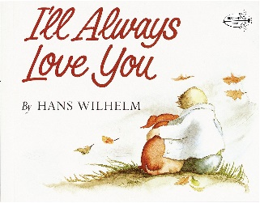
4.43: I'll Always Love You by Hans Wilhelm (1985)
A child’s sadness at the death of a beloved dog is tempered by the remembrance of saying to it every night, “I’ll always love you.”

Video Link: https://www.youtube.com/watch?v=BtY3kyGzqjc (4:01)

5.0: Music, Videos, and Related Resources for Children

No resources identified

6.0: Curriculum & Theme-Based Classroom Activities for Children for Mercy & Forgiveness

from Tapestry of Faith
Mercy
6.1: Creating Home: A Program on Developing a Sense of Home Grounded in Faith for Grades K-1
6.1.1: Session 14: Comings and Goings
Link: https://www.uua.org/re/tapestry/children/home/session14/59755.shtml
“Participants will:
- Listen and respond to the central story, The Lost Son [i.e., The Prodigal Son, which also is a story about mercy]
- Experience the story through dramatic play with stick puppets
- Apply the theme of coming and going to their own lives in a rhythmic chant
- Explore homecomings in their own families
- Experience losing and finding something in a game”

6.2: Moral Tales, A Program on Making Choices for Grades 2-3
6.2.1 Session 8: Do unto Others

Link: https://www.uua.org/re/tapestry/children/tales/session8
“Participants will:
- Participate in the "Gems of Goodness" exercise
- Hear a story illustrating an act of compassion for a stranger
- Participate in a cooperative game in which they think about how they would like to be treated, and have an opportunity to treat others with care
- Imagine how they might apply the Golden Rule to a variety of scenarios
- Visualize and portray the concept that all people are our neighbors”
Note: The story of the Good Samaritan is a classic introduction to mercy withheld and mercy extended to a stranger.

6.3: Amazing Grace: A Program about Exploring Right and Wrong for Grade 6
6.3.1: Session 8: UUs In Action

Link: https://www.uua.org/re/tapestry/children/grace/session8
“Participants will:
- Explore Christian scriptural attitudes toward social justice through the stories of the good shepherd and the lost sheep [which is a classic story about mercy]
- Play roles in a hypothetical scenario where ethical decisions are demanded
- Question the role faith plays in their decision-making process
- Hear how one UU incorporates social justice themes in his music
- Optional: Find magazine accounts of UU social justice projects”

6.4: Building Bridges: A World Religions Program for 8th-9th Grades
6.4.1: Workshop 16: Evangelical Christianity

Link: https://www.uua.org/re/tapestry/youth/bridges/workshop16
“Participants will:
- Deepen understanding of the contemporary American Evangelical Christian movement—its theology and its religious, cultural, and political expressions
- Relate to the concept of being "born again" through reflection on their own experiences of rebirth or transformation
- Consider the theology, practice, and popularity of Evangelical Christianity in the United States today and explore how this movement meets its adherents' religious needs
- Explore how Unitarian Universalist values and principles can guide them in encounters with fundamentalist and/or evangelical Christian people, ideas, and practices.”
- [Hear and discuss in Activity 3 Feeding the Hungry: an Interfaith Story, which is one of the classic works of mercy]

6.5: A Chorus of Faiths: A Program That Builds Interfaith Youth Leaders
6.5.1: Workshop 2: We Need Not Think Alike to Love Alike

Link: https://www.uua.org/re/tapestry/youth/chorus/workshop2
“Participants will:
- Understand the Golden Rule as an example of a Unitarian Universalist value inherited from our Judeo-Christian tradition
- Learn the story of the Unitarian Universalist flaming chalice symbol and hear about the interfaith service work of Unitarians Martha and Waitstill Sharp during World War II [which is a story that also involves mercy]
- Map their community's assets for diverse, interfaith cooperation in service work
- Move the group's interfaith service project forward by identifying potential partners and projects in their community
- Recognize and reflect on the importance of human similarities and differences.”
- [Explore the Ethic of Reciprocity through the story of the Good Samaritan which is a story about mercy]

6.5.2: Workshop 6: Spreading the Good News

Link: https://www.uua.org/re/tapestry/youth/chorus/workshop6
“This workshop will:
- Introduce the importance of practicing religious pluralism effectively in doing interfaith work”
- [In Activity 1: Facilitating Interfaith Dialogue participants will explore texts from nine religious traditions that explore the importance of service, some of which relate to works of mercy]

Forgiveness
6.6: Wonderful Welcome: A Program for Children Grades K-1
6.6.1: Session 3: The Gift of Forgiveness
Link: https://www.uua.org/re/tapestry/children/welcome/session3
“This session will:
- Introduce forgiveness as an intangible gift
- Explore situations where forgiveness is appropriate and identify ways to express forgiveness
- Show how forgiveness helps us live our Unitarian Universalist Principles, especially the first Principle (inherent worth and dignity of every person) and the second Principle (justice, equity and compassion in human relations)
- Demonstrate that authentic welcoming must include a readiness to forgive
- Engage participants in the spiritual practices of opening and closing rituals”

6.7: Love Surrounds Us: A Program on the UU Principles and Beloved Community for Grades K-1
6.7.1: Session 4: Forgiveness
Link: https://www.uua.org/re/tapestry/children/lovesurrounds/session4
“This session will:
- Identify words and phrases around forgiveness
- Introduce the Unitarian Universalist idea that we believe all people should be treated fairly (second Principle)
- Discover the joy in using the words, ‘I forgive you.’”

6.8: Moral Tales: A Program on Making Choices for Grades 2-3
6.8.1: Session 5: Forgiveness
Link: https://www.uua.org/re/tapestry/children/tales/session5
“This session will:
- Foster participants’ pride in sharing acts of goodness and justice that they have done (or witnessed)
- Create a forum for children to share with one another about acts of goodness and justice
- Introduce the concept of forgiveness
- Guide participants to share their own experiences of anger, hurt, love and forgiveness
- Lead participants to experience forgiveness of self or another person.
- Help participants reflect on an act of kindness another person has done for them”

6.9: Faithful Journeys: A Program about Pilgrimages of Faith in Action for Grades 2-3
6.9.1: Session 2: Unconditional Love, a Gift from Our Universalist Heritage
Link: https://www.uua.org/re/tapestry/children/journeys/session2
“Participants will:
- Learn about a childhood experience of Universalist preacher Hosea Ballou, that exemplifies key Universalist beliefs about universal salvation and love, both of which point to forgiveness
- Experience their congregation as a place where they are loved and give unconditional love to others, despite imperfections, as they identify and affirm some of their own strengths and interests
- Name ways they might act that respond to the signpost “Respect Everyone”
- Name ways they have translated faith into action by participating in the Faithful Footprints exercise
- Take responsibility for creating a safe learning environment by reviewing and signing the Faithful Journeys group covenant.”

6.10: Love Will Guide Us: A Program for Grades 2-3 that Applies the Wisdom of the Six Sources to the Big Questions
6.10.1: Session 13: Responding with Love
Link: https://www.uua.org/re/tapestry/children/loveguide/session13
“Participants will:
- Hear a story from the Sufi tradition that models responding to meanness with kindness
- Experience a calming dancing meditation
- Practice transforming negative situations and attitudes with positive words.”

6.11: Windows and Mirrors: A Program about Diversity for Grades 4-5
6.11.1: Session 4: Building A Community of Forgiveness
Link: https://www.uua.org/re/tapestry/children/windows/session4
“Participants will:
- Practice the skills of offering forgiveness to those who have broken a covenant
- Connect their own thoughts and experiences with a story about a group of Buddhist students’ experience of covenant and forgiveness
- Articulate ways they express and consider ways to enforce the group covenant
- Understand how practicing forgiveness helps heal hurt feelings
- Commit to practicing at home forgiveness skills learned during the session.”

6.12: Toolbox of Faith: A Program That Helps Children Discover the Uses of Faith, Grades 4-5
6.12.1: Session 15: Atonement (Level)
Link: https://www.uua.org/re/tapestry/children/toolbox/session15
“Participants will:
- Learn the vocabulary words, ‘atonement’ and ‘reconciliation’
- Understand how the tool, a level, symbolizes the restoration of balance that comes with ‘at-one-ment’ or atonement
- Hear a true story illustrating how some Unitarian Universalists made a mistake and, later, a new generation of Unitarian Universalists tried to restore balance, to atone
- Play games that illustrate concepts related to atonement, including disarray and unity and the difficulties of assigning blame
- Express a form of reconciling prayer in the process of handling and baking bread
- Discuss their feelings on the value of restoring balance, at-one-ment, by making an apology.”

6.13: Heeding the Call: A Program on Justice-making for Junior High School Youth
6.13.1: Workshop 11: The Call for Forgiveness
Link: https://www.uua.org/re/tapestry/youth/call/workshop11
“This workshop will:
- Identify forgiveness as a quality needed to bring about a more just world
- Demonstrate that forgiveness is connected to the inherent worth and dignity of every person (first Principle)
- Explore forgiveness as a challenging and rewarding activity
- Examine forgiveness on different levels, both large and small.”

Resources for Youth & Adults
7.0: Reflections, Readings, Stories & Poetry

7.1: Works of Mercy by Sister Marilyn Sunderman (283 words)

Feed the Hungry: In the Book of Proverbs, we read: “A generous person will be blessed for she or he shares food with the poor.”
…Globally, 3 million children die of malnutrition each year.

Give Drink to the Thirsty: Jesus said: “Whoever gives to one of these little ones even a cup of cold water … shall not lose his or her reward.” …For many people, safe, drinkable water is not readily available. …For almost a billion people [people must walk] …at least four miles a day [to get water.]

Clothe the Naked: In Luke’s gospel, Jesus instructs the person who has two coats to share with another who has none. …Millions of people cannot afford to purchase adequate clothing to protect themselves from the elements. …

Visit the Sick: …Jesus encountered many sick people. He reached out in love to those suffering from illness; he spoke encouraging words to them; sometimes, he physically touched them; and he healed them of their maladies. …

Visit the Imprisoned: Jesus said: “I was in prison and you came to me.” …Life in prison can be very hard…. Prisoners look forward to visits; they appreciate others’ taking time to be with them.

Shelter the Homeless: …[For many different reasons,] “…it is estimated that 150 million people are homeless worldwide” and some “1.6 billion people around the world live in ‘inadequate shelter.’” …

Bury the Dead: …Burying the dead is based on the sacredness of the human person. …It is a way of demonstrating that the life of the deceased was valued and continues to have value….

Engage in the Works of Mercy: …Pope Francis has said that what our world needs is the medicine of mercy….
Source: http://www.sistersofmercy.org/blog/2017/01/23/compassion-in-action-reflections-on-matthew-25/

7.2: Justice versus Mercy by Rev. Fred Wooden (117 words)
Justice is pictured as a scale held by a blindfolded woman, equity without bias. John Rawls defined justice as fairness, as a society premised on no one having automatic and systemic advantage or disadvantage.
The Bible's famous “eye for an eye” is an ancient version, in which justice cannot claim more than was taken. But, as someone [i.e., Gandhi] noted, “an eye for an eye eventually makes the whole world blind.”
We all make errors, and, without mercy, we would all owe more than we can pay.
So, mercy is the wisdom and courage not to exact justice when it would create continued or additional harm. Mercy sees that, sometimes, forgiveness is more just than mere justice.
Source: https://www.mlive.com/opinion/grand-rapids/2016/06/the_difference_between_justice.html

7.3: Motley Mercy by Anne Lamott (257 words)
We’re so often rattled by lingering effects of trauma and paralyzing fear.
At first glance, they seem inextricable. Trauma, which is sorted differently in the brain than memory, seeps out of us as warnings of worse to come. Our self-centered fears whisper at us all day: our fear of exposure, of death, and that we will lose those we love most, that we will lose whatever advantage we hold, whatever meager gains we’ve made. We live in terror that our butts will show and people will run from us, screaming.
But let’s say we believe that mercy and forgiveness are in fact foundational, innate, what we are grown from and can build on; also that they are hard to access because of these traumas and fears. What if we know that forgiveness and mercy are what heal and restore and define us, that they are the fragrance that the rose leaves on the heel that crushes it? So why today is it absolutely all I can do to extend mercy to myself for wanting to nip an annoying relative’s heel like a river rat? Forget extending mercy to this relative, who has so messed with me and my son—she doesn’t even know she needs my mercy. She thinks she is fierce and superior, while I believe she secretly ate her first child. Horribly, she is perfectly fine. I’m the one who needs mercy—my mercy. The need for this, for my own motley mercy, underpinned most of my lifelong agitation, my separation from life and self.
Source: Hallelujah Anyway: Rediscovering Mercy by Anne Lamott (2017)

7.4: The Beatitudes from Matthew 5:3-12 (143 words)
3 Blessed are the poor in spirit: for theirs is the kingdom of heaven.
4 Blessed are they that mourn: for they shall be comforted.
5 Blessed are the meek: for they shall inherit the earth.
6 Blessed are they which do hunger and thirst after righteousness: for they shall be filled.
7 Blessed are the merciful: for they shall obtain mercy.
8 Blessed are the pure in heart: for they shall see God.
9 Blessed are the peacemakers: for they shall be called the children of God.
10 Blessed are they which are persecuted for righteousness’ sake: for theirs is the kingdom of heaven.
11 Blessed are ye, when men shall revile you, and persecute you, and shall say all manner of evil against you falsely, for my sake.
12 Rejoice, and be exceeding glad: for great is your reward in heaven: for so persecuted they the prophets which were before you.
Source: https://www.uua.org/re/tapestry/youth/bridges/workshop11/leader-resource4

7.5: Let Micah Do It by Anne Lamott (255 words)
There are times in our lives—scary, unsettling times—when we know that we need help or answers but we’re not sure what kind, or even what the problem or question is. We look and look, tearing apart our lives like we’re searching for car keys in our couch, and we come up empty-handed. Then when we’re doing something stupid, like staring at the dog’s mismatched paws, we stumble across what we needed to find. Or even better, it finds us. It wasn’t what we were looking or hoping for, which was usually advice, approval, an advantage, safety, or relief from pain. I was raised to seek or achieve them, but like everyone, I realized at some point that they do not bring lasting peace, relief, or uplift. This does not seem fair, after a lifetime spent in their pursuit. Where, then, do I turn in these increasingly frightening days? Where do I look for answers when I’m afraid, or confused, or numb? To an elegant Japanese sage? A dream-dancing Sioux grandmother with a tinkling laugh? No. More often than not, the North Star that guides me through the darkness is the Old Testament prophet Micah. He must have looked like a complete stoner or a Game of Thrones extra, and smelled like a goat, yet nearly three thousand years ago, he spoke the words that often remind me of my path and purpose: “What doth God require of thee but to do justice and to love mercy, and to walk humbly with thy God?”
Source: Hallelujah Anyway: Rediscovering Mercy by Anne Lamott (2017)

7.6: Being More Than Broken by Bryan Stevenson (273 words)
I frequently had difficult conversations with clients who were struggling and despairing over their situations—over the things they’d done, or had been done to them, that had led them to painful moments. Whenever things got really bad, and they were questioning the value of their lives, I would remind them that each of us is more than the worst thing we’ve ever done. I told them that if someone tells a lie, that person is not just a liar. If you take something that doesn’t belong to you, you are not just a thief. Even if you kill someone, you’re not just a killer.
…I am more than broken. In fact, there is a strength, a power even, in understanding brokenness, because embracing our brokenness creates a need and desire for mercy, and perhaps a corresponding need to show mercy. When you experience mercy, you learn things that are hard to learn otherwise. You see things you can’t otherwise see; you hear things you can’t otherwise hear. You begin to recognize the humanity that resides in each of us.
…I began thinking about what would happen if we all just acknowledged our brokenness, if we owned up to our weaknesses, our deficits, our biases, our fears. Maybe if we did, we wouldn’t want to kill the broken among us who have killed others. Maybe we would look harder for solutions to caring for the disabled, the abused, the neglected, and the traumatized. I had a notion that if we acknowledged our brokenness, we could no longer take pride in mass incarceration, in executing people, in our deliberate indifference to the most vulnerable.
Source: Just Mercy: A Story of Justice and Redemption by Bryan Stevenson (2014)

7.7: Works of Mercy from Matthew 25: 35-40 (142 words)
For I was hungry, and you gave Me something to eat; I was thirsty, and you gave Me something to drink; I was a stranger, and you invited Me in; ³⁶ naked, and you clothed Me; I was sick, and you visited Me; I was in prison, and you came to Me.’ ³⁷ Then the righteous will answer Him, ‘Lord, when did we see You hungry, and feed You, or thirsty, and give You something to drink? ³⁸ And when did we see You a stranger, and invite You in, or naked, and clothe You? ³⁹ When did we see You sick, or in prison, and come to You?’ ⁴⁰ The King will answer and say to them, ‘Truly I say to you, to the extent that you did it to one of these brothers of Mine, even the least of them, you did it to Me.’
Source: Matthew 25: 35-40

7.8: Arrogance R Us by Anne Lamott (191 words)
“What doth God require of thee but to do justice and to love mercy, and to walk humbly with thy God?”
Oh, is that all? Justice, mercy, and humility? That’s nice. Right off the bat I can tell you that “walk humbly with thy God” is not going to happen anytime soon, for me or my closest friends. Arrogance R Us. My humility can kick your humility’s butt. What Micah is talking about is grad school curriculum, while, spiritually speaking, I remain in junior high school, superior and cringing at the same time. And “to do justice” may be a trick, since we all think we do this anyway. We think that if our values aren’t the correct ones, we would have other ones, which would then be the correct ones.
Otherwise, these words are both plainsong and sublime. How can you not love mercy—kindness, compassion, forgiveness? It’s like not loving dessert, or cheese. If nothing makes people happier than service, especially to the poor, why not tap into the model of the Buddha, Jesus, or Wavy Gravy, the knowledge that if you do loving things, you’ll have loving feelings?
Source: Hallelujah Anyway: Rediscovering Mercy by Anne Lamott (2017)

7.9: Mercy Unexpected by Adam Makos and Larry Alexander (206 words)
The pilot glanced outside his cockpit and froze. He blinked hard and looked again, hoping it was just a mirage. But his co-pilot stared at the same horrible vision.
“My God, this is a nightmare,” the co-pilot said.
“He’s going to destroy us,” the pilot agreed.
The men were looking at a gray German Messerschmitt fighter hovering just three feet off their wingtip. It was five days before Christmas 1943, and the fighter had closed in on their crippled American B-17 bomber for the kill.
The B-17 pilot, Charles Brown, was a 21-year-old West Virginia farm boy on his first combat mission. His bomber had been shot to pieces by swarming fighters, and his plane was alone in the skies above Germany. Half his crew was wounded, and the tail gunner was dead, his blood frozen in icicles over the machine guns.
But when Brown and his co-pilot, Spencer “Pinky” Luke, looked at the fighter pilot again, something odd happened. The German didn’t pull the trigger. He nodded at Brown instead. What happened next was one of the most remarkable acts of chivalry recorded during World War II. Years later, Brown would track down his would-be executioner for a reunion that reduced both men to tears.
Source: A Higher Call: An Incredible True Story of Combat and Chivalry in the War-Torn Skies of World War II by Adam Makos and Larry Alexander

7.10: Put Away Childish Things? by Anne Lamott (280 words)
Just to hear the words “mercy” or “merciful” can transform the whole day, because as the old saying goes, the soul rejoices in hearing what it already knows. Something lights up in me. We know mercy is always our salvation—as we age, as our grandchildren go down the same dark streets that called to their parents, as the ice caps melt. But I wish it was something else. I wish it was being able to figure things out, at which I am very good, or to assign blame, at which I am better, or to convince people of the rightness of my ideas. I wish it was a political savior who believes the same things I believe, who possesses the force of great moral strength that (of course) agrees with my own deepest values. But no, hope of renewal and restoration is found in the merciful fibrillating heart of the world.
Mercy, within us and outside us, all around us, silent invisible mercy—really? In the face of Rwanda, Nixon, ISIS, malaria, your father, and your wife’s god-awful sister, and what children did to you or your own kids in the playground? Really? There has to be another way to feel free and fully alive. And anyway, I tried. I came into this world with mercy for nearly everyone, everywhere, and for all cats and dogs at the pound. A fat lot of good it did me. By five years old, I had migraines and the first signs of OCD. By about age six, along with innocence and wonder and truth, I put away childish things. They said to, the people in charge of keeping me alive. I did.
Source: Hallelujah Anyway: Rediscovering Mercy by Anne Lamott (2017)

7.11: Capable of Great Gifts by Chris Harrington (259 words)
As a young family on a graduate student budget, we have become accustomed to packing our own food for travel. With this in mind, we often try to pack a little bit extra in case we should meet someone in need.
On one of these family journeys, we happened to pass a homeless man begging for spare change. As we approached him in our car, Katrina and I invited our 4-year-old son, Ryan, to help gather a bit of food to pass along to the old man. He greeted us with a warm, weathered smile, and a profound sense of gratitude. While the encounter lasted just a few moments it has remained with our eldest since.
Ryan had dozens of questions about the grizzled old man we had met on the side of the road. Who was he? Why didn’t he have food? Where did he live? Where were his friends and family?
I take it for granted that there are many who lack basic human needs, but the idea was completely foreign to our little ones who have never experienced serious want. The concept of homelessness was particularly hard for Ryan to grasp, and he returned to it constantly over the subsequent months.
…Feeding the hungry and giving drink to the thirsty are two of the simplest opportunities to engage our youngsters. I was surprised to learn as much from watching them as they have from me. Children have the ability to see the world with new eyes, marked by abundant compassion and gilded with a humble awe.
Source: http://faith.nd.edu/s/1210/faith/interior.aspx?sid=1210&gid=609&pgid=30667&cid=60275&ecid=60275&crid=0&calpgid=28560&calcid=57094

7.12: Condemned by the Absence of Mercy by Bryan Stevenson (215 words)
Proximity has taught me some basic and humbling truths, including this vital lesson: Each of us is more than the worst thing we’ve ever done. My work with the poor and the incarcerated has persuaded me that the opposite of poverty is not wealth; the opposite of poverty is justice. Finally, I’ve come to believe that the true measure of our commitment to justice, the character of our society, our commitment to the rule of law, fairness, and equality cannot be measured by how we treat the rich, the powerful, the privileged, and the respected among us. The true measure of our character is how we treat the poor, the disfavored, the accused, the incarcerated, and the condemned.
We are all implicated when we allow other people to be mistreated. An absence of compassion can corrupt the decency of a community, a state, a nation. Fear and anger can make us vindictive and abusive, unjust and unfair, until we all suffer from the absence of mercy and we condemn ourselves as much as we victimize others. The closer we get to mass incarceration and extreme levels of punishment, the more I believe it’s necessary to recognize that we all need mercy, we all need justice, and—perhaps—we all need some measure of unmerited grace.
Source: Just Mercy: A Story of Justice and Redemption by Bryan Stevenson (2014)

7.13: Welcome to Vengeance World by Anne Lamott (189 words)
I came here with a huge open heart, like a big, sweet dog, and I still have one. But some days the only thing that can cheer me up is something bad happening to someone I hate, preferably if it went viral and the photo of the person showed hair loss and perhaps the lifelong underuse of sunscreen. My heart still leaps to see this. I often recall the New Yorker cartoon of one dog saying to the other: “It’s not enough that we succeed. Cats must also fail.” This is the human condition, that in the face of death, cats must lose.
An open, merciful heart is a setup for pain, shame, and being mocked. We are not stupid: welcome to Vengeance World. The original wound was our parents’ belief in punishment: spanking, shame, exile, the silent treatment, isolation. It was pretty convincing.
I’m not sure I even recognize the ever-presence of mercy anymore, the divine and the human; the messy, crippled, transforming, heartbreaking, lovely, devastating presence of mercy. But I have come to believe that I am starving to death for it, and my world is, too.
Source: Hallelujah Anyway: Rediscovering Mercy by Anne Lamott (2017)

7.14: Charged with Murder, Clinging to Mercy by Matthew Flynn (266 words)

When I volunteered with the Catholic ministry at the county jail, I didn’t know what to expect about the men I would interact with.
…The ministry I joined did largely the same thing week to week—we talked about different aspects of …faith, prayed with the inmates about their intentions and needs, had faith sharing conversations, and led prayer services and devotions on Saturday mornings.
…I was often surprised by sudden changes in our group's population. Since jails are transitional facilities, we hardly ever had the exact same group of people more than once.
…I started to build a rapport with some of the longer-tenured inmates, but I had no idea what kind of impact (if any) we were having on them until one of them came up to me one day.
He told me that in a few weeks he was being extradited to another state for a crime he had committed there (murder) and asked me to pray for him and his family. He did not deny his crime or give any excuses, as some others did. He just simply stated it, like a fact. Then, after a long pause, added that he was glad to be going back to his home state, but that he would miss us and hoped that they had something similar where he was going.
…Sometime after that, before he was extradited, I saw him approach the priest in the corner for the Sacrament of Reconciliation. In the days before he left, I could see tears welling in his eyes whenever we talked about God's love, mercy, and forgiveness.
Source: http://faith.nd.edu/s/1210/faith/interior.aspx?sid=1210&gid=609&pgid=30338&cid=59721&ecid=59721&crid=0&calpgid=28560&calcid=57094

7.15: What is Mercy? by Anne Lamott (244 words)
Maybe it would be helpful to ask what we mean when we speak or dream of mercy.
…Mercy is radical kindness. Mercy means offering or being offered aid in desperate straits. Mercy is not deserved. It involves absolving the unabsolvable, forgiving the unforgivable. Mercy brings us to the miracle of apology, given and accepted, to unashamed humility when we have erred or forgotten. Charge it to our heads and not our hearts, as the elders in black churches have long said. Mercy, grace, forgiveness, and compassion are synonyms, and the approaches we might consider taking when facing a great big mess, especially the great big mess of ourselves—our arrogance, greed, poverty, disease, prejudice. It includes everything out there that just makes us sick and makes us want to turn away, the idea of accepting life as it presents itself and doing goodness anyway, the belief that love and caring are marbled even into the worst life has to offer.
… Mercy means that we soften ever so slightly, so that we don’t have to condemn others for being total shits, although they may be that. (Okay: are.) If I do so, it makes me one. As Father Ed Dowling said, sometimes heaven is just a new pair of glasses. When we put them on, we see the awful person, sometimes even ourselves, a bit more gently, and we are blessed in return. It seems, on the face of things, like a decent deal.
Source: Hallelujah Anyway: Rediscovering Mercy by Anne Lamott (2017)

7.16: The Shame of Poverty in Hollywood by Stephanie DePrez (467 words)

When I moved to LA …my identity shift from teacher at a Jesuit high school to unemployed aspiring Hollywood playmaker was [humiliating.]

…I returned to my car on Manhattan Beach …and a ticket for $150. Knowing I had around $15 in my bank account, I began to cry.

…I was out of options and so, detached from myself, I drove to Dolores Mission.

…I slipped into the last pew…. When the service …ended, I looked up.

… “Hi, Father Mike. I used to come here with high schoolers. …Reading my blotchy eyes and feral appearance, he invited me into his office.

I was prepared …share my woes…. I got about 30 seconds in before Fr. Mike stopped me and said, “I’m a social worker….” He addressed my debt, my student loans, my rent, health insurance, and suggested I consider going to therapy.

“How about we walk through the food shed before you go?”

I began to panic. “But that food is for… poor people.”

“Well, I hate to break it to you….”

I thought about my dwindling pantry and the last time I’d eaten. I nodded.

“How are you on gas?”

“I, uh, can get home, but then I don’t get paid till next week.”

“I think the Society of Jesus can sponsor a tank of gas.”

…Now, for someone who has passionately taught the concept of “downward mobility,” …I was failing my own test. The shame and embarrassment with which I met my poverty of goods was indicative of the real poverty inside of me: a poverty of humility. …I had become the poor, those I spent years claiming to admire, and I couldn’t stand it.

…I didn’t tell anyone for weeks, but when I did, whoever I was speaking with would say, “Oh, yeah, I was there.” …I thought. “So many people have been one paycheck from ruin and nobody talks about it!”

But that’s the thing—once the ground is firm, and hope is established, the shame and humility of poverty begin to fade. We don’t want to identify with it anymore. And that, I think, is the real tragedy.

In recent weeks I’ve started three new jobs, and I no longer panic about rent. It is worrisome how quickly I forget that $30 to buy groceries for the week is something that a fifth of the people in America don’t have.

We live in a world of excess and aspirations of indulgence. I park next to Teslas and drive past Beverly Hills mansions, but none of this is what I truly desire. The way to remain immune to this culture of addictive financial self-improvement is to stay as close to the poor as possible. I must remind myself to be grateful for what I have, and to pass on whatever else may come.
Source: http://faith.nd.edu/s/1210/faith/interior.aspx?sid=1210&gid=609&pgid=30504&cid=60013&ecid=60013&crid=0&calpgid=28560&calcid=57094

7.17: When Mercy Fails by Bryan Stevenson (312 words)
I looked at the clock. It was 6:30 P.M. Mr. Dill [who I had represented] was dead by now. I was very tired, and it was time to stop all this foolishness about quitting. It was time to be brave. I turned to my computer, and there was an email inviting me to speak to students in a poor school district about remaining hopeful. The teacher told me that she had heard me speak and wanted me to be a role model for the students and inspire them to do great things. Sitting in my office, drying my tears, reflecting on my brokenness, it seemed like a laughable notion. But then I thought about those kids and the overwhelming and unfair challenges that too many children in this country have to overcome, and I started typing a message saying that I would be honored to come. On the drive home, I turned on the car radio, seeking news about Mr. Dill’s execution.
… I turned off the radio station, as I slowly made my way home, I understood that even as we are caught in a web of hurt and brokenness, we’re also in a web of healing and mercy. I thought of the little boy who hugged me outside of church, creating reconciliation and love. I didn’t deserve reconciliation or love in that moment, but that’s how mercy works. The power of just mercy is that it belongs to the undeserving. It’s when mercy is least expected that it’s most potent—strong enough to break the cycle of victimization and victimhood, retribution and suffering. It has the power to heal the psychic harm and injuries that lead to aggression and violence, abuse of power, mass incarceration.
I drove home broken and brokenhearted about Jimmy Dill. But I knew I would come back the next day. There was more work to do.
Source: Just Mercy: A Story of Justice and Redemption by Bryan Stevenson (2014)

7.18: Unloveliness is Always on Tap by Anne Lamott (270 words)
When we manage a flash of mercy for someone we don’t like, especially a truly awful person, including ourselves, we experience a great spiritual moment, a new point of view that can make us gasp. It gives us the chance to rediscover something both old and original, the sweet child in us who, all evidence to the contrary, was not killed off, but just put in the drawer. I realize now how desperately, how grievously, I have needed the necessary mercy to experience self-respect. It is what a lot of us were so frantic for all along, and we never knew it. We’ve tried almost suicidally for our whole lives to shake it from the boughs of the material world’s trees. But it comes from within, from love, from the flow of the universe; from inside the cluttered drawer.
My unloveliness, on the other hand, is always on tap, like draft beer—my boring self-obsession, pettiness, and schadenfreude. Wearing my bad pair of glasses, I look around and see that I am surrounded by swine. How do you expect me to react?
But God, in Her guise as Coyote Trickster, gooses me, and I accidentally let go. I take a break from being prickly and judgmental.
… What’s the catch? The catch is that there is no catch. This is so subversive. All I have to do in order to begin again is to love mercy, if I am to believe nutty old Micah. Then creation begins to float by, each new day. Sometimes it’s beauty, cherries, calm, or hawks; sometimes it’s forbearance, stamina, eyeglass wipes, apricots, aspirin, second winds.
Source: Hallelujah Anyway: Rediscovering Mercy by Anne Lamott (2017)

7.19: Mercy Overflowing by Nicky Gumbel (282 words)
When Nelson Mandela left prison after twenty-seven years and became South Africa’s first democratically elected president, he called upon his old friend, Desmond Tutu, to chair The Truth and Reconciliation Commission. This commission was a series of hearings—some of them public—in which both victims and perpetrators gave testimony about their experiences and actions during apartheid.
At one of the hearings, a policeman called van de Broek told of how he and his fellow officers shot an eighteen-year-old youth, then burnt the body. Eight years later they went back, took the father and forced his wife to watch as he was incinerated. She was in court to hear this confession and was asked by the judge what she wanted. She said she wanted van de Broek to go to the place where they had buried her husband’s body and gather up the dust so that she could give him a decent burial. Van de Broek agreed.
She then added a further request. “Mr van de Broek took all my family away from me, and I still have a lot of love to give. Twice a month I would like for him to come to the ghetto and spend a day with me so that I can be a mother to him. And I would like Mr van de Broek to know that he is forgiven by God, and that I forgive him too. I would like to embrace him so he can know that my forgiveness is real.” Spontaneously, some in the courtroom began singing Amazing Grace as the elderly woman made her way to the witness stand. But van de Broek did not hear the hymn, he had fainted, overwhelmed.
Source: https://bibleinoneyear.org/bioy/commentary/94

7.20: The Prodigal Cat by Anne Lamott (181 words)
I’m the older brother in the parable of the prodigal son. I am also the younger brother, who returns to his father’s home, dissipated and desperate, willing to work alongside the servants in the fields for food and shelter, who is instead welcomed home by his father, rejoiced in, wept over. But not, of course, by his morally excellent, priggish older brother, with his clipboard and Protestant work ethic. Having never deserted the family, he now has to watch his father throw a dance and banquet for his horrible loser baby brother. He, meanwhile, has everything he ever longed for—an exquisite life. But it’s not enough. The father beseeches him, “We have to celebrate and be glad, because this brother of yours was dead and is alive again; he was lost and is found.” But the older brother isn’t having any of it. He won’t go inside the banquet room to the feast and the music. He says, “No, Dad. The cats must lose.” When we leave him, he’s angry, and still outside.
This is me, the bitter goody two-shoes.
Source: Hallelujah Anyway: Rediscovering Mercy by Anne Lamott (2017)

7.21: Do we deserve to kill? by Bryan Stevenson (308 words)
[At his funeral service,] I felt the need to explain to people what …[Walter "Johnny D." McMillian, who I had represented and who was exonerated for a wrongful conviction] had taught me. Walter made me understand why we have to reform a system of criminal justice that continues to treat people better if they are rich and guilty than if they are poor and innocent. A system that denies the poor the legal help they need, that makes wealth and status more important than culpability, must be changed. Walter’s case taught me that fear and anger are a threat to justice; they can infect a community, a state, or a nation and make us blind, irrational, and dangerous. I reflected on how mass imprisonment has littered the national landscape with carceral monuments of reckless and excessive punishment and ravaged communities with our hopeless willingness to condemn and discard the most vulnerable among us. I told the congregation that Walter’s case had taught me that the death penalty is not about whether people deserve to die for the crimes they commit. The real question of capital punishment in this country is, “Do we deserve to kill?”
Finally, and most important, I told those gathered in the church that Walter had taught me that mercy is just when it is rooted in hopefulness and freely given. Mercy is most empowering, liberating, and transformative when it is directed at the undeserving. The people who haven’t earned it, who haven’t even sought it, are the most meaningful recipients of our compassion. Walter genuinely forgave the people who unfairly accused him, the people who convicted him, and the people who had judged him unworthy of mercy. And in the end, it was just mercy toward others that allowed him to recover a life worth celebrating, a life that rediscovered the love and freedom that all humans desire, a life that overcame death and condemnation until it was time to die [as he said] on God’s schedule.
Source: Just Mercy: A Story of Justice and Redemption by Bryan Stevenson (2014)

7.22: Mercy to People with no Bootstraps by Anne Lamott (285 words)
Mercy creates a future for the downtrodden, hopeless, and hungry. The Book of Ruth tells the story of a young Moabite woman’s love for her Jewish mother-in-law, Naomi, after the death of Naomi’s sons, one of whom was Ruth’s husband. Ruth’s love and loyalty induced her to leave her homeland: “Where you go, I will go, your God will be my God, and your people my people.” She accompanied Naomi back to the land of Israel, across the Jordan River. Ruth was a survivor—she adjusted, in chaos, to new surroundings, and found a job as a farm worker, willing to be a gleaner in the fields, gathering up leftover grain and grapes, so she and Naomi could eat. Ruth was very real—she’d been slapped around by life. She was practical, and faithful: We’ll eat, there’s a roof over our heads, we’ll be friendly to each other. Such blessing.
Her devotion, loyalty, and hard work came to the attention of a Jewish landowner named Boaz, who had instructed his laborers to leave behind extra grain in the field. Gleaning creates a larger consciousness, that we are all in this together, symbiotically. It’s an infinitely more merciful theory than trickle-down, where we’ll collect everything and keep the best on top, and maybe some will spill over for the bootstrap people to fight over. No: the wheat, the grapes, are already there. Just don’t take them all. Always leave some behind. Goodness and hope can come out of that—in the smallest gestures: sharing some of your food, picking up litter, helping search for the lost, welcoming home the found. Then you have open doors that had been shut, with moments of holy kindness and generosity….
Source: Hallelujah Anyway: Rediscovering Mercy by Anne Lamott (2017)

7.23: Unlocking Mercy by Father Ron Raab, CSC (260 words)
Last year I was called to the hospital to anoint a woman dying of cancer.
…When I arrived at the door of her hospital room, I knocked lightly. I entered and saw the woman in bed near the door. A heavy-set officer sat on the other side of her bed, just a couple of feet away. I bent down at her bedside and she immediately began speaking about her faith. …She had a profound faith that embraced her experience with cancer.
As I bent down and slowly opened the container of oil, my eyes caught the handcuffs dangling from the officer’s belt. The more I tried to focus on the intimacy of the moment and the profound encounter with her ailing body, I could not help but have one eye on the handcuffs that were reminding her of the earthly ties that still bound her. The more I spoke with her and prayed with her, the more I felt that she was one of the most spiritually free people I had met in a long while.
This image of the handcuffs and the anointing remains with me. We all seek the freedom…, yet we are all bound by past decisions and lives that have not turned out as we had planned.
…These are the people whom Jesus longs to hold, to heal, and to forgive. This is the bedside of liberation and love. As my years of experience creep up on me, I surrender to such mercy because I do not have any other answers that will set people free.
Source: http://faith.nd.edu/s/1210/faith/interior.aspx?sid=1210&gid=609&pgid=30772&cid=60469&ecid=60469&crid=0&calpgid=28560&calcid=57094

7.24: Do You Want to be Right or Good? by Anne Lamott (284 words)
Kindness toward others and radical kindness to ourselves buy us a shot at a warm and generous heart, which is the greatest prize of all. Do you want this, or do you want to be right? Well, can I get back to you on that? I want to want this softening, this surrender, this happiness. Can I get a partial credit for that? The problem is, I love to be, and so often am, right. It’s mood-altering, and it covers up a multitude of sins. A sober friend of mine says, “I don’t notice that I’m hungry and angry. I just notice that I’m right.” I know justice and believing that you’re right depend on cold theological and legal arguments where frequently there is no oxygen, but honestly, I don’t mind this. I learned to live in thin air as a small child.
…The good news is that God has such low standards, and reaches out to those of us who are often not lovable and offers us a chance to come back in from the storm of drama and toxic thoughts.
… The storm outside is just so much more enlivening, and for a writer, much better material. Plus, I can be a hero in my storm, which is where I found a sense of value as a child, as the tense little EMT in a damaged family. Crisis, self-centered fear, and saving people were home for me, with a wet bar serving up adrenaline. The quiet, tranquil room of just being was boarded up. But love reaches out and reaches out and reaches out. It is staggering that it is always giving me another chance, another day, over and over and over.
Source: Hallelujah Anyway: Rediscovering Mercy by Anne Lamott (2017)

7.25: The Broken Among Us Teach Us by Bryan Stevenson, author of Just Mercy
What sustains me is this knowledge I have that it’s really the broken among us that can contribute a lot to our quest for full, equal justice. When you’re broken, you actually — you know something about what it means to be human. You know something about grace. You learned something about mercy. You learned something about forgiveness. It’s the broken among us that can teach us some things. And knowing that you don’t have to be perfect and complete gives you a way of moving through challenge that would be hard if you think that that’s not something that’s possible.
And so, I tell my young staff, you can’t do this work, you can’t be in some of the painful places we’re in, you can’t hold children who’ve been abused, and not be impacted by that. You’re going to shed some tears. You are. And you’re gonna be overwhelmed, you’re going to get tired, you’re gonna get pushed down — all of those things are going to happen, and it doesn’t mean you’re weak. It doesn’t mean that you’re not up to the task. It doesn’t mean you’re incompetent or incapable. It just means you’re a human being. And that’s what I want: I want human beings.
And so, what sustains me is, in part, this knowledge that I can’t always feel confident and sure and clear; that there are gonna be times when it’s uncertain what’s going to happen. And I’ve tried to appreciate that.
Source: https://www.awakin.org/read/view.php?tid=2482

7.26: Let’s be Brothers Again by Anne Lamott (320 words)
I’ve tried to teach my Sunday-school kids this as the ultimate mercy story, but they won’t have it. They can’t relate to Ruth, who is too pure. But they always like the story of Joseph in Genesis, Joseph of the coat of many colors, because there are evil brothers and a merciful hero to whom they can relate, and best of all, blood. Joseph’s brothers, jealous of their father’s love for him and disturbed by his creepy prophetic dreams, sold him into Egyptian slavery as a child. They killed a goat and poured its blood onto his beautiful coat, and showed it to their father, Jacob, as proof that his most beloved son had been killed by wild beasts. (This is why the kids love the story.) Joseph ended up in Pharaoh’s court, and because of his prophetic dreams slowly rose to be the powerful food czar in the court. He saved Egypt and the surrounding countries from famine. His brothers, starving in nearby Canaan, came to Egypt seeking food, and when it was their turn to petition Joseph, they didn’t recognize him. He recognized them and was very harsh at first, until they spoke of his father and youngest brother, the baby, Benjamin. Then his heart softened. He showed them mercy on steroids: first he forgave them, and then he gave them a future. They had made him homeless, but he gave them a home, near him, in Pharaoh’s favor. They went back to Canaan for Jacob and Benjamin, and the family was made whole again.
…Mercy is: Let’s be brothers again. Let’s sit at table. Joseph was in tears of grief and love at the end of the story, with the men who destroyed his life and his father’s. He showed the brothers who they were—as beloved and cared for as the youngest—and the story shows how we were, too, before we put away childish things.
Source: Hallelujah Anyway: Rediscovering Mercy by Anne Lamott (2017)

8.0: Curriculum & Theme-Based Classroom Activities for Youth & Adults
Youth

8.1: Videos
8.1.1: Seven Acts of Mercy was our Mission at World Youth Day (2:45)
In Rio de Janeiro, we set out on a mission …to those who needed it most. See the images, view the faces, understand the depth of …mercy in the actions of these missionaries.
Video Link: https://www.youtube.com/watch?v=OTJDi7adcTg

8.2: Curriculum
8.2.1: A Chorus of Faiths: A Program That Builds Interfaith Youth Leaders
8.2.1.1: Workshop 2: We Need Not Think Alike to Love Alike

Link: https://www.uua.org/re/tapestry/youth/chorus/workshop2
“Participants will:
- Understand the Golden Rule as an example of a Unitarian Universalist value inherited from our Judeo-Christian tradition
- Learn the story of the Unitarian Universalist flaming chalice symbol and hear about the interfaith service work of Unitarians Martha and Waitstill Sharp during World War II [which is a story that also involves mercy]
- Map their community's assets for diverse, interfaith cooperation in service work
- Move the group's interfaith service project forward by identifying potential partners and projects in their community
- Recognize and reflect on the importance of human similarities and differences.”
- [Explore the Ethic of Reciprocity through the story of the Good Samaritan which is a story about mercy]

8.2.1.2: Workshop 6: Spreading the Good News

Link: https://www.uua.org/re/tapestry/youth/chorus/workshop6
“This workshop will:
- Introduce the importance of practicing religious pluralism effectively in doing interfaith work”
- [In Activity 1: Facilitating Interfaith Dialogue participants will explore texts from nine religious traditions that explore the importance of service, some of which relate to works of mercy]

8.2.2: Virtue Ethics: An Ethical Development Program for High School Youth

8.2.2.2: Workshop 7: Compassion

Link: https://www.uua.org/re/tapestry/youth/virtueethics/workshop7
“Participants will:
- Explore the meaning of compassion
- Discuss a dilemma where compassion is called for [via the story of the Good Samaritan where Jesus concludes with these words, ‘Now which of these three do you think seemed to be a neighbor to him who fell among the robbers?’ He said, ‘He who showed mercy on him.’ Then Jesus said to him, ‘Go and do likewise.’]
- Identify experiences when they have, or have not, used compassion, and commit to practicing the virtue of compassion in a particular aspect of their life”

Adults
8.3: Resistance and Transformation: An Adult Program on Unitarian Universalist Social Justice History
8.3.1: Workshop 1: Introductions

Link: https://www.uua.org/re/tapestry/adults/resistance/workshop1

A significant focus of this workshop (50 minutes) focuses on the story of the Good Samaritan, which is a classic story of mercy refused and mercy extended.

9.0: Popular Music (Mercy & Forgiveness)

Mercy

9.1: Looking for Mercy by Madonna (4:50)
Video Link: https://www.youtube.com/watch?v=kMG6HVRd8lA

9.2: Rescue by Lauren Daigle (3:48)
Video Link: https://www.youtube.com/watch?v=gYR0xP1j4PY

9.3: In the Arms of The Angel by Sarah Mclachlan (4:30)
Video Link: https://www.youtube.com/watch?v=SnL1e4-NfaA

9.4: I Dreamed a Dream by Anne Hathaway (4:29)
Video link: https://www.youtube.com/watch?v=dmHcDWrMH-8

9.5: Laughing With by Regina Spektor (3:16)
Video Link: https://www.youtube.com/watch?v=-pxRXP3w-sQ

9.6: Beautifully Broken by Plumb (3:23)
Video Link: https://www.youtube.com/watch?v=ce6PT-3sQGg
9.7 Mercy by Shawn Mendes (4:09)
Video Link: https://www.youtube.com/watch?v=KkGVmN68ByU
9.8: Goodness, Love, and Mercy by Chris Tomlin (7:38)
Video Link: https://www.youtube.com/watch?v=8Qa6zZrYkZA
9.9: Mercy by Brett Young (4:02)
Video Link: https://www.youtube.com/watch?v=Thvm6dADOms
9.10: Have Mercy by Eryn Allen Kane (3:35)
Video Link: https://www.youtube.com/watch?v=uImvs9X9duY
9.11: No Mercy by The Stranglers (3:38)
Video Link: https://www.youtube.com/watch?v=DpxWxXIpeEg
9.12: Mercy, Mercy Me by Marvin Gaye (3:11) & Charlie Losiewicz (6:43)
Video Link: https://www.youtube.com/watch?v=U9BA6fFGMjI
Video Link: https://vimeo.com/306316381
Forgiveness
9.13: I Forgive It All by Mudcrutch (song by Tom Petty) (4:46)
Video Link: https://www.youtube.com/watch?v=jezqNxQ8mb0

9.14: Forgiveness by Sarah McLachlan (3:51)

Video Link: https://www.youtube.com/watch?v=cP0mOOZGJKo

9.15: Forgiveness by John Mellencamp (4:30)

Video Link: https://www.youtube.com/watch?v=Go_MiO58AlM

9.16: Moment of Forgiveness by Indigo Girls (3:11)

Video Link: https://www.youtube.com/watch?v=BUe2lKYw6jQ

9.17: Jealous Guy by John Lennon and The Plastic Ono Band (w/ the Flux Fiddlers) (4:14)

Video Link: https://www.youtube.com/watch?v=wADRRYNHhOA

9.18: Forgiveness by Diane Birch (5:09)

Video Link: https://www.youtube.com/watch?v=_zBG4sl7MyM

9.19: Wings of Forgiveness by India Arie (4:56)

Video Link: https://www.youtube.com/watch?v=qxMLZjqZ8wE

9.20: Praying by Kesha (4:59)

Video Link: https://www.youtube.com/watch?v=v-Dur3uXXCQ

9.21: Forgiveness by Collective Soul (5:02)

Video Link: https://www.youtube.com/watch?v=dcGy-BT5suk

9.22: Forgive by Rebecca Lynn Howard (3:53)

Video Link: https://www.youtube.com/watch?v=VTFX0Q7rq-E

9.23: I Forgive You by Kellie Pickler (3:33)

Video Link: https://www.youtube.com/watch?v=rFC20P25mZ4

9.24: Forgiveness by TobyMac [Lyrics] ft. Lecrae (4:14)

Video Link: https://www.youtube.com/watch?v=xfkhqpl81NA

9.25: Hurt by Christina Aguilera (4:31)

Video Link: https://www.youtube.com/watch?v=wwCykGDEp7M

9.26: Forgiveness by Macy Gray (5:22)

Video Link: https://www.youtube.com/watch?v=z9KR9JZgehc
9.27: Forgiven by Crowder (3:55)
Video Link: https://www.youtube.com/watch?v=u_ZWEO36jok
9.28: Forgiveness by Matthew West (4:25) & (3:48)
Video Link: https://www.youtube.com/watch?v=h1Lu5udXEZI

Video Link: https://www.youtube.com/watch?v=FMn0QNdiuGE

10.0: Videos, Short Films, Movie Clips, Audio Recordings & Photography about Mercy
10.1: The Story of Guan Yin, Avalokiteśvara Goddess of Compassion and Mercy by Little Lemuria (4:57)
A thoughtful retelling of the Buddhist origin story of Guan Yin, Goddess of Mercy.
Video Link: https://www.youtube.com/watch?v=kXzl9B8cjwo

10.2: Mercy by Jonathan Weir (5:06)
A song and story about the mercy of love and new life. Features song Her Mercy by Glen Hansard
Video Link: https://vimeo.com/260704609

10.3: Finding Mercy trailer by Robyn Paterson (2:54)
This is a trailer to the 2012 documentary about a girl named Mercy who was left behind in Zimbabwe under the rule of Mugabe. Mercy’s childhood friend, a white girl, now grown with her own daughter is obsessed with learning what happened to Mercy. Mugabe was a dictator who ruled Zimbabwe for 40 years until 2017. He brutalized his subjects. So, Finding Mercy has two meanings, finding Mercy and trying to determine where you can find mercy, if anywhere, in a brutal society.
Video Link: https://vimeo.com/40136444

10.4: Mercy in Action by Mercy Ships (4:53)
Mercy is also to be found in compassion and kindness through medical care. Watch to learn how our volunteer crew, on the world's largest charity hospital ship, the Africa Mercy, provides medical care and neighborly love on a daily basis.
Video Link: https://vimeo.com/45470136

Ted Talks
10.5: The Magic of Humanity: Forgiveness, Mercy and Compassion by Rais Bhuiyan (15:24)
Rais Bhuiyan an American Muslim from Bangladesh, is an extraordinary individual with a powerful story. After serving as an air force pilot in Bangladesh, Rais moved to the United States in 1999 to study computer technology. Ten days after 9/11, Rais was the victim of a horrific hate crime. Shot in the face at point blank range by white supremacist, Mark Stroman, self-described “the Arab slayer,” Rais barely survived. Sadly, two other victims were killed. Stroman was sentenced to death; ten years later, Rais led an international campaign, fighting to save Stroman’s life. Rais’ near death experience and subsequent religious pilgrimage sparked a profound journey of soul searching and began his path as a human rights activist for peace, forgiveness, empathy and understanding. Rais’ effort to save Stroman from execution in 2011 was unsuccessful, but his transformative ability to turn hate into compassion and forgive the unforgivable has been transformative.
Video Link: https://www.youtube.com/watch?v=v4uEVdGoBik

